PC Blues

Upgrade Suite

Version 2.0

MANUAL

Introduction 4
Important! 5
Year 2000 Compliance 5
Disclaimer 5
Terminology 6
Requirements 7
Software 7
Hardware 7
Experience 7
Features 8
Upgrade Suite Client Features 8
Upgrade Suite Server Features [Server Only] 8
Installation 9
Uninstalling Upgrade Suite 10
Quick Start 11
Getting Ready 11
Creating a Project 11
A Local/Network Deployment 12
An Internet Deployment 13
Preparing the Project 13
Deploying the Project 13
Publishing a Link to the Project 14
Getting Upgrade Suite Client Ready for the Quick Start Lesson 14
Using the Upgrade Suite Client to Install the Project 15
Upgrade Suite Client Manual 16
User Interface 17
Configuring Upgrade Suite Client 18
Registering a Project 18
Installing a Project 18
Restoring Overwritten System Files 19
Backing Up a Project 19
Upgrading a Project 19
Uninstalling a Project 20
Completely Removing a Project 20
Redeploying a Project 20
Refreshing a Redeployment 22
Other Functions of Upgrade Suite Client 22
Upgrade Suite Server Manual [Server Only] 23
User Interface 23
Project Planning Considerations 23
Creating and Editing a Project 27
Adding and Editing Project Folders 27
Adding and Editing Project Files 27
Preparing a Project 28
Testing a Project 28
Deploying a Project 29
Managing the Deployment of Files 30
Publishing Project Links 30
Pulling Down a Project 30
Other Functions of Upgrade Suite Server 30
Upgrade Suite Transmitter Manual 31
Upgrade Suite Distribution Manager Manual [Server Only] 32
Reference 33
Upgrade Suite Client 33
Client Preferences 42
File Saver 45
Upgrade Suite Server [Server Only] 47
Project Wizard [Server Only] 56
Folder Wizard [Server Only] 66
File Wizard [Server Only] 67
Internet Settings 69
Transmitter Settings 71
Upgrade Suite Transmitter 72
Upgrade Suite Distribution Manager [Server Only] 73
The Log Screen 76
Security 78
Passwords 78
Project Definition File 78
Security of FTP Protocol 78
Inherent Security of Patches 78
Using Client ID’s as a Software License Key 78
Conclusion 79
Software License 80
Purchasing Details 80
Alterations to Upgrade Suite 80
Redistribution of Upgrade Suite 80
Disclaimer of Warranty 81
Glossary 82

Introduction
Welcome to PC Blues’ Upgrade Suite. This is an integrated set of tools that will allow you to distribute data and software across networks, intranets and the internet. It contains many features that enable you to deploy and maintain these distributions in a wide variety of scenarios.
Note!
These text boxes, which appear throughout the manual, contain important information about the operation of Upgrade Suite, including limitations and side-effects of certain actions.

Please read these sections before using Upgrade Suite:
Important!
Terminology
Requirements
Installation
Security

This manual contains references to the features and functionality of all components of Upgrade Suite. Some of these are only available in the Server version of this product. The headings of these sections will be annotated with “[Server Only]”.

A broad list of the features of Upgrade Suite can be found in the Features section.

For a quick hands-on tutorial to get you up and running with Upgrade Suite, refer to the Quick Start section.

For an in-depth description of the functionality of Upgrade Suite, refer to the Reference section. This section contains descriptions of each of the separate functions the different components of Upgrade Suite, and how to access them using toolbar buttons and/or menu items. The functions are listed in alphabetical order for each component. The following format is used:

Foo ← Name of the function
← An image of the toolbar button for the function (if one exists)
File >> Foo ← How to access the function using the main menu ( in this case, click on File, and then click on Foobar using the left mouse button)

For information about the user interface and how to use separate components of the Upgrade Suite, refer to the sections:
Upgrade Suite Client Manual
Upgrade Suite Server Manual
Upgrade Suite Transmitter Manual
Upgrade Suite Distribution Manager Manual

License conditions are contained in the Software License section.

Descriptions of the terminology used in the product and its documentation can be found in the Glossary and the Terminology sections.

Important!
There are many possible configurations of networking software and hardware. Therefore, PC Blues strongly recommends testing this product on your network in the way you intend to use it in production, with the files and data you intend to distribute.

If you have any problems or questions, discover a bug, or have any suggestions for improvements to the software, email support@pcblues.com and we will work with you to try to solve your problem. PC Blues will try to respond as soon as possible to your request, but please allow up to two working days to receive an initial reply to your email.

This product is commercial software. As such, it is not freeware, and not shareware. Demonstration versions of the software are fully functional, but time limited to 40 days from date of the installation of the product.

Year 2000 Compliance

No date functions or comparisons are used in any of the software in the Upgrade Suite. This will guarantee Year 2000 compliance to the extent that your operating system software and computer hardware is not subject to Year 2000 problems.

Disclaimer

By using this software, you agree to indemnify PC Blues, it’s owners, staff, and associates from responsibility for any damages or loss of data that result directly or indirectly from the use of this software. Remove Upgrade Suite from your computer if you do not agree to this.

Terminology
Because of the wide range of applications provided for by Upgrade Suite, we use words that can encompass a broad range of meanings. When a special meaning applies to an innocuous looking term, we will start that term with Capital Letters.

A full glossary of terms can be found in the help file, and in the Glossary section of this manual. However, three terms in particular are important to mention now:

Project
A Project can be a software application, a set of files, one file, data, or documentation collected together for distribution using the Upgrade Suite. It is the “basic unit” on which Upgrade Suite operates.

Administrator
The person/company who makes a Project and distributes it. Examples of a Project Administrator include software houses, individual programmers working from home, a department in a company, or a network administrator. A Project can contain contact information for the Administrator, so that users of the project can easily contact them via email, or go to their website.

Folder / Directory
These words are used interchangeably throughout Upgrade Suite and it’s documentation. There is a subtle difference between to meanings of the two words, but where the difference is important to the operation of Upgrade Suite, appropriate explanations are included in the documentation. If you are still interested in what the differences are, here is an explanation (albeit rudimentary).

There are special folders in Windows that can be pointed to a particular directory on the computer’s hard drive. These folders have names like Desktop, My Documents, Favourites, System, etc. So that different users on the same computer can have their own desktop, document and favourites folders, the Desktop folder for one user will point to a different directory on the computer to the Desktop folder of another user, and so on with the different folders. Another use for folders is the ability of Windows to be installed to any directory name on your computer that you want. However, the location of this directory is stored in one place in the computer’s registry so that programs will be able to find the Windows directory no matter where it is. A directory, on the other hand, is a physical place on the computer’s hard drive. If you don’t know the name of a directory, you cannot find it.

Requirements

Software

Microsoft Windows 95/98/NT/2000/ME.

In order to make use of some of the features in the Upgrade Suite Client, the computer requires an internet browser, and an email client.

This software has not been tested with Microsoft Windows 2000 or ME. Contact PC Blues Technical Support (support@pcblues.com) if you are experiencing problems operating Upgrade Suite in these environments.

Hardware

Any PC which can operate Microsoft Windows 95/98/NT/2000/ME. However, it should be noted that depending on how you intend to use Upgrade Suite, operations on old or slow computers could take an inordinately long time to execute, especially when being performed with large files. Testing if your computers can process your deployment needs in a reasonable time is recommended.

Experience

Intermediate experience in the operating systems being used in your deployment of Upgrade Suite will be very useful.

For internet-based deployments, an understanding of access and configuration of FTP and HTTP servers is required.

For network-based deployments, an understanding of Windows Networking is required.

Features

Upgrade Suite Client Features

- Simple / Advanced user interfaces
- Support for combined installation media (e.g. CD-ROM and internet)
- Repair of corrupted installations (manual and automatic)
- Silent mode available for upgrading distributions on client PC’s
- Only files that have been modified are downloaded and installed
- Support for backing up of installed distribution before upgrading
- Support for rolling back upgrade to previous version
- Support for replacement of files currently in use
- Support for software uninstallation
- Support for contacting particular software author and visiting their website
- Continuation of interrupted file downloads
- Support for restoration of previous versions of Windows and System files
- View/Print/Save log of all actions
- Support for proxy servers
- Extensive online help

Upgrade Suite Server Features [Server Only]

- Easily create distributions of data and software for deployment to local area networks, intranets, and the internet
- Automatic creation of patches for upgrading distributions
- Support to locally test internet-based distributions
- Distribution can be restricted to certain computers
- Scheduled distributions
- Software publishers can supply upgrades to external client bases over the internet
- View/Print/Save log of all actions
- Support for proxy servers
- Extensive online help

Installation
There are two distributions of Upgrade Suite available.

The Client distribution contains the Upgrade Suite Client and Upgrade Suite Transmitter, which is sufficient for computers which will only have the Upgrade Suite Client installed. This enables them to register, install, upgrade and redeploy Projects.

The Server distribution contains all the Upgrade Suite tools: Upgrade Suite Server, Upgrade Suite Client, Upgrade Suite Transmitter, and Upgrade Suite Distribution Manager. This distribution provides all the functionality available in Upgrade Suite.

The two distributions of Upgrade Suite also have demonstration versions. These are time limited (40 days from installation). They are fully functional and identical to the full versions except for notifying the user of the number of days left after each component is closed.

If you are installing the full version of a distribution on a computer with the demonstration version already installed, or installing the Server distribution on a computer with the Client version already installed on it, install it to the previous installation directory. Otherwise, Upgrade Suite will lose track of Projects that the user has created, or installed. They can be recovered by copying certain folders on your hard drive, but following this advice will save you the trouble.

Uninstalling Upgrade Suite
Double-click on Add/Remove Programs in your Windows Control Panel, and remove PC Blues Upgrade Suite from there.

Don't uninstall Upgrade Suite Server or Upgrade Suite Client through the Upgrade Suite Client interface.

Quick Start
This section will describe the quickest and easiest way to deploy an example Project and make it available to other users.

To complete these Quick Start instructions, you need to have the Server distribution installed.

The demonstration version of the software is adequate. This can be obtained from the PC Blues website (http://www.pcblues.com/software/usuite.html).

Getting Ready

First, we will collect the files for our Project in a directory on the C drive. Open Windows Explorer, and create a folder called QuickstartProject in the root directory of the C drive.

Go into the directory and create a text file called readme.txt. Open the file in notepad.exe, and enter some text. Exit and save the file.

Using Windows Explorer, navigate to your computer’s Windows directory. In it, you will find a file called NOTEPAD.EXE. This is the Windows NotePad program. Copy this file to the C:\QuickstartProject directory.

Using Windows Explorer, navigate to your computer’s Windows System directory. If you are using Windows 95 or Windows 98, the Windows System directory will be a subdirectory of your Windows directory called SYSTEM. For example, if Windows has been installed to a directory called C:\win98, the System directory will be C:\Win98\System. If you are using Windows NT 4, the System directory will be a subdirectory of the Windows directory called SYSTEM32. In this directory you will find a file called REGSVR32.EXE. Copy this file to the C:\QuickstartProject directory.

You should now have three files in the c:\QuickstartProject directory.

Creating a Project

Open the Upgrade Suite Server. You will find this in the Start Menu under Programs/Upgrade Suite.

Click on the Help menu item and make sure there is a tick next to “Show Hint Boxes”. This will make a box appear on most screens in Upgrade Suite that give you online hints about how to enter data when you drag your mouse over various elements of the user interface.

Select Project >> New Project. If you have already created a Project, you will prompted whether to clear the current Project Definition information. If so select Yes.

You will then be prompted to enter a Project name. Enter “Quick Start Project” and click OK.

You will then be prompted to enter a filename for the Project Definition File. Enter “quickstart” and click OK.

You will be prompted to import a directory structure. Click Yes. A folder browsing dialog will be opened. Browse to C:\QuickstartProject and click OK. You will be prompted to recurse subdirectories. Click Yes or No. It doesn’t matter for the Quick Start lesson.

The Project Wizard will now be displayed. Notice that some of the items in the first wizard screen have already been filled in. The Project ID is generated by Upgrade Suite Server, and is a unique identifier for this Project. The name of the Project you entered and the filename for the Project Definition File are displayed. The name of the directory you selected to import files from has been entered as the Source Directory for the Project.

It is time to enter a Default Target Directory. This is the directory that the Upgrade Suite Client will install the Project into by default. Enter C:\QSPinstall into this setting.

Select REGSVR32.EXE from the Main File drop down list. This will be the file that is executed when the Project is run in Upgrade Suit Client.

Select readme.txt from the Readme File drop down list. You can edit this file by clicking on the Edit button to the right of this setting.

Enter 1.0 into the Version setting. Enter http://www.pcblues.com into the Administrator Website setting. Enter your email address into the Administrator Email setting.

You have now completed the first screen of the Project Wizard. Click on the Next button.

Choose now whether you want to deploy your Project to an FTP server, or to a local or network drive.

To deploy your Project to a local directory, you have no special requirements at this point. Follow the directions in the section Quick Start - A Local/Network Deployment.

To deploy your Project to an FTP server, make sure you have a user name and password that gives you the rights to create and delete files and directories on the FTP server. Also, for testing, make sure you have HTTP access to the same directories on the computer on which you are going to be running Upgrade Suit Client (it can, of course, be the same computer as the one on which you are running Upgrade Suite Server). Then follow the directions in the section Quick Start - An Internet Deployment below.

A Local/Network Deployment

In this example, we will be deploying a Project to the C drive, but the same applies if you want to deploy a Project to a Windows Networking server using UNC notation (e.g. \\SERVERNAME\SHAREDDIRECTORYNAME ) , or a mapped network drive (e.g. Z:\SHAREDDIRECTORYNAME ).

The current page of the Project Wizard should display the titles, “Project Transmission Settings” and “Project Preparation Settings”.

Firstly, make sure the Transmission Type setting is set to “Local/Network Directory”.

Now enter “C:\QSPdeploymentarea” into the setting for Deployment Directory. This is the directory that Upgrade Suite Server will use as the Deployment Area for the Project.

Enter “C:\QSPdeploymentarea” into the setting for Client Deployment Path. This is the directory that the Upgrade Suite Client will use as the Deployment Area for the Project.

Leave the other settings as they are and click Next. The Project Scheduling screen will appear. Click Next again. The Project Dependencies screen will appear. Click Next again. The Project Distribution Targets screen will appear. Click Finish. The screens we skipped over now will be covered in the section Upgrade Suite Server Manual.

Continue with the instructions in the section Quick Start - Preparing the Project.

An Internet Deployment

In this example, we will be deploying a Project to an FTP server, so that the Upgrade Suite Client can retrieve it via HTTP.

The current page of the Project Wizard should display the titles, “Project Transmission Settings” and “Project Preparation Settings”.

First, make sure the Transmission Type setting is set to “FTP Server”.

Enter your FTP server address into the FTP Server Address setting ( e.g. ftp.nowhere.com).

In the Deployment Directory setting, enter the directory on the FTP server you wish to deploy the Project to ( e.g. webpages/projects/qsp ) This is the directory on the FTP server that Upgrade Suite Server will use as the Deployment Area for the Project.

Enter your username and password for the FTP server.

In the Client Deployment Path setting, enter the HTTP address that will point the Upgrade Suite Client to the same directory as the Deployment Directory. It might be http://www.nowhere.com/projects/qsp. This is the directory that the Upgrade Suite Client will use as the Deployment Area for the Project.

Leave the other settings as they are and click Next. The Project Scheduling screen will appear. Click Next again. The Project Dependencies screen will appear. Click Next again. The Project Distribution Targets screen will appear. Click Finish. The screens we skipped over now will be covered in the section Upgrade Suite Server Manual.

Preparing the Project

Project Preparation is a function of Upgrade Suite Server where it collects all the latest versions of a Project’s files together and creates any patches as needed.

Click on Tools >> Prepare and follow the prompts. The Project is now ready to deploy.

Deploying the Project

Click on Tools >> Deploy. The Upgrade Suite Transmitter will be launched to deploy the Project. When it is finished, click File >> Normal Exit to close the Transmitter.

The Project is now in the Deployment Area, where Upgrade Suite Client can access to install the Project.

Publishing a Link to the Project

Click on Tools >> Publish. We are going to create a shortcut file. Select “Create Windows Shortcut” and click OK. This will create a shortcut file on the Windows Desktop.

Close Upgrade Suite Server be clicking on Project >> Exit Upgrade Suite Server.

Getting Upgrade Suite Client Ready for the Quick Start Lesson

Open the Upgrade Suite Client and select Options >> Preferences from the menu. Make sure the following options have been set.

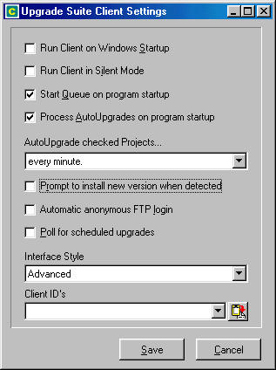
Click on Save, and then exit Upgrade Suite Client by clicking on File >> Normal Exit.

Using the Upgrade Suite Client to Install the Project

On your desktop you should find an icon called Quick Start Project. It will look like this:

Double click on this icon, and Upgrade Suite Client will open and the Quick Start Project will be registered with the Upgrade Suite Client.

You will be prompted to choose an installation directory for the Quick Start Project. Click Yes. The Project will be installed, and you will be prompted to read the readme file. Select Yes, and the file that you set as the readme file in the Project will be opened in Windows Notepad.

If the Upgrade Suite Client is not displaying the “Installed” tab, click on it. If the Project has installed correctly, you will see it there.

Double click on “Quick Start Project” and it will run.

You will see this screen, which is the program that we copied from the Windows directory. Click OK.

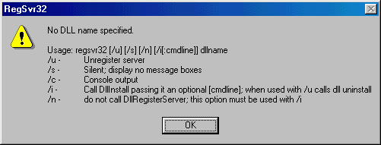
Congratulations! You have successfully deployed and installed a Project. For a complete treatment of all the features of Upgrade Suite, we recommend you read through the major sections with Manual in the title.

Upgrade Suite Client Manual
When the Upgrade Suite Client is launched an icon will be displayed in the System Tray next to the clock. Right clicking on this icon will give you the option to show, hide, and exit Upgrade Suite Client. Double-clicking on this icon will bring Upgrade Suite Client to the front of your screen.

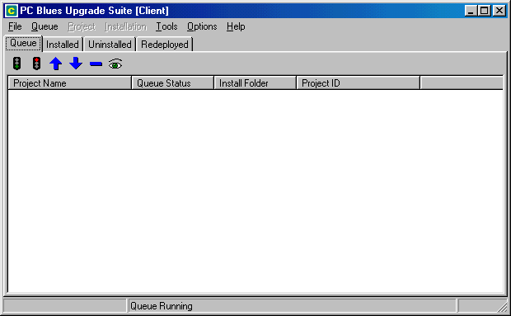

After Upgrade Suite Client has been installed, you may want to change the initial configuration to suit your own purposes. See Configuring Upgrade Suite Client below for instructions on how to do this.

The functionality of Upgrade Suite Client can be grouped into two major categories- the installation and maintenance of Projects, and, the redeployment of Projects. The redeployment functions will only be needed by people who are responsible for the deployment of Projects throughout an organisation.

The Upgrade Suite Client manages the installation and upgrades of Projects on a single computer. Depending on its configuration, it can run when Windows is started, automatically check Projects to see if there is a new version available, and repair corrupted installations.

When the Upgrade Suite Client is running, it displays an icon in the Windows system tray. This is (usually) in the bottom right hand corner of your screen, next to the time. This can be used to access the Client by double-clicking on it.

User Interface

There are four tabs on the Upgrade Suite Client screen which contain lists of Projects that have been registered on the computer.

Queue
The Queue tab contains a list of projects that are queued for upgrading or installing. The Project at the top of the list is processed first, and then removed from the queue.

The Queue can be manually started and stopped, and items can be manually removed from it. Items are added to it by the user when he/she chooses to upgrade or install a Project. Upgrade Suite Client can also add items to the queue if a Project is configured to be automatically upgraded or installed. Projects can be moved up and down the Queue in order to prioritize them.

Installed
The Installed tab displays a list of installed projects. Only projects that have had all of their files installed successfully are displayed in this list.

Projects in the Installed list can be launched by the user. In a Project’s Project Definition File, one file in a distribution can be selected to be the Main File. This usually will be an executable file, in which case the program will be run. However, it could also be a document or spreadsheet that will be opened in it’s associated application when the Project is launched.

A Project also contains provision for electing a file to be the Project’s Readme File. This file can be opened by the user in it’s associated application, or if there is none, in Windows Notepad. This file can be a text file, HTML, etc.

There is provision for a Project to contain an email address and a website address. These can be invoked by the user from the toolbar of the Installed Projects view, but will work for projects in any project list in Upgrade Suite Client. The functions only work if the email address and website address have been included in the Project by the Project’s author.

Uninstalled
The Uninstalled tab contains a list of uninstalled or partially installed projects. If the Upgrade Suite Client has registered a Project for the first time, the name of the Project will intially appear here, unless Upgrade Suite Client has been configured to install a Project as soon as it is registered.

Redeployed
The Redeployed tab is not visible if the user interface is in “Simple” mode (see Reference – Client Preferences)

Redeployments allow one computer to maintain an up to date version of a Project that is available across a slow network medium (e.g. the internet over a modem), and make it available for distribution over a faster network environment (e.g. a local area network). This way, a large number of computers can efficiently have the latest version of a Project installed on them, with only one computer downloading the latest version over a slow network link.

Likewise, an advantage to this method of distributing Projects is that a network administrator can control the version of a Project that is installed across a network.

Server Time-Out Display

When a file is being downloaded from an HTTP or FTP server during a Project’s installation, the number of seconds remaining before Upgrade Suite times out is displayed in the bottom right hand corner of the Upgrade Suite Client screen.

A busy or slow file server can create problems for a Project’s installation or upgrade. If an installation fails, you can try to install the Project again, and Upgrade Suite Client will start from where it left off.

Configuring Upgrade Suite Client

The configuration of Upgrade Suite Client immediately after it is installed may not be suitable for your own purposes. See Reference – Client Preferences for more information.

Registering a Project

For a Project to be installed or upgraded with Upgrade Suite Client, it must be registered with it first. There are two ways to register a Project with Upgrade Suite Client.

Double-clicking on a Project Definition File or opening it from inside a web browser will register the file with Upgrade Suite Client if it has not already been registered. Note, though, that opening the file directly out of a web browser may not work. If this is the case, save the file from the web browser to your hard disk, and double-click on it from the directory in which you save the Project Definition File.

Project Definition Files can also be opened from inside the Upgrade Suite Client (see Reference – Upgrade Suite Client – Load Project Definition File)

Installing a Project

When a Project is being installed for the first time, all the files of the Project will be downloaded from the Deployment Area of the Project and installed in the Project’s Installation Directory. Depending on the configuration of Upgrade Suite Client, it may install the program into the Project’s Default Installation Directory, or it may prompt the user to select or create an Installation Directory.

See Reference – Upgrade Suite Client – Install a Project

After installation, there is two ways to tell if there were any problems with the downloading and installation of files. If the Install Status of the Project does not show Installed, and the Project appears in the Uninstalled tab list of Projects, there is at least one file that is missing from the Project’s installation directory.

If you are notified that a Project installation will be complete when you reboot your computer, Upgrade Suite Client will be the first program that runs when you reboot your computer. It will then complete the installation of your Project.

Restoring Overwritten System Files

A commonly occurring problem with Windows installations of software is when one application overwrites a Windows DLL with a newer or older version of the file. This can cause other software on the computer system to stop operating correctly.

If this occurs after installing or upgrading a Project using Upgrade Suite Client, you can use the File Saver to restore the system DLL that no longer works.

See Reference – File Saver for more information.

Backing Up a Project

When you are upgrading a Project and Upgrade Suite Client is not in Silent Mode (see Reference – Upgrade Suite Client - Edit Preferences) you will be prompted to back up the current version of the Project. If you choose to back up the Project, the current version of the Project will be backed up.

If the upgrade is not successful, or the new version of the Project is buggy, you will then be able to restore the Project to the most recently backed up version ( see Reference – Upgrade Suite Client – Roll Back Project to Previous Version)

Upgrading a Project

Project’s are displayed in the Upgrade Suite Client in the Installed and Uninstalled tabs with a checkbox to the left of them. This is the AutoUpgrade option. If it is checked, the Project will have it’s installation checked every so often. The interval of time between checks for a new version is determined by the Upgrade Suite Client preferences (see Reference – Upgrade Suite Client – Edit Preferences). If a Project is found to have a new version available or the current installation has been corrupted in any way, the latest version will be downloaded and installed.

If the latest version of a Project is installed, the Version Status of the Project will say “Latest”. If a new version of a Project is available, the Version Status of the Project will display the version of the Project that is available.

The user can download the latest version of the Readme File of the Project to see if the new version is desirable ( see Reference – Upgrade Suite Client – View Latest Version of Project’s Readme File).

When a Project is being updated, Upgrade Suite Client will only download and install the files that need to be updated. If there is a patch available for an existing file, the patch will be downloaded and combined with the existing file to create the new version of the file.

After an upgrade, if all the files latest versions of the Project are in place, the Version Status of the Project will say “Latest”.

Upgrading Files Currently in Use

Upgrade Suite Client can upgrade Projects that are currently in use. If it is unable to copy a new version of a file over an old one because it is currently locked by the system, it will copy the new file to it’s rightful place the next time the computer is rebooted.

If you are notified that a Project upgrade will be complete when you reboot your computer, Upgrade Suite Client will be the first program that runs when you reboot your computer. It will then complete the installation of your Project.

Uninstalling a Project

Uninstalling a Project deletes a Project’s files from the Installation Directory of a Project, and deletes the Project’s Windows Shortcuts. If there are no files left in the Installation Directory of the Project, it will also delete the Installation Directory of the Project.

The Project will be displayed in the Uninstalled tab of the Upgrade Suite Client user interface, and the Installation Status of the Project will be “Uninstalled”.

Uninstalling a Project does not delete files and directories created by the Project. Nor does it remove Read-Only files.

To completely remove a Project from Upgrade Suite Client, see the section below.

See Reference – Upgrade Suite Client – Uninstall a Project

Completely Removing a Project

A Project can be completely removed from the user’s computer.

When a Project is registered and installed with Upgrade Suite Client, it appears in the user interface, a directory is set up to contain working files for the Project’s installation and upgrading, and files are installed into the Project’s Installation Directory. All of these files and entries are deleted when a Project is removed completely.

See Reference – Upgrade Suite Client – Remove a Project Completely

Redeploying a Project

This is one of the most advanced features of Upgrade Suite Client, and will not be needed by most users of Upgrade Suite.

Redeployment of a Project means taking a Project that has been installed on a computer using Upgrade Suite Client and making it available to other users on the network, intranet or internet. The version of a Project that is currently installed on the user’s computer will be the version of the Project that is available to users who install the redeployed Project.

When a user Redeploys a Project, they are prompted to enter the details of where the redeployed Project is going to be stored so that it can be accessed by other users.

There are two ways to redeploy a Project. It can be redeployed to an FTP server, so that other users can access it using HTTP, or it can be redeployed to a network directory, or locally, so that other users on a network with access to the directory which the Project was redeployed to can install and upgrade the Project.

The screens that the user is prompted to fill in are subsets of the screens that users of Upgrade Suite Server fill in to create and deploy a new Project. The descriptions of the settings can be found in the Upgrade Suite Server section of the manual.

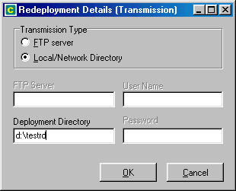

See Reference – Project Wizard – Project Transmission Settings

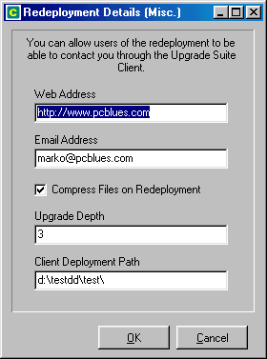

See Reference – Project Wizard – Project Preparation Settings

Refreshing a Redeployment

The Redeployed tab of the Upgrade Suite Client user interface contains a list of all the Projects that have been redeployed from the user’s computer. This tab is not visible if the Upgrade Suite Client user interface preference is set to “Simple Mode” ( see Reference – Upgrade Suite Client – Edit Preferences).

Redeployed Projects can be set to AutoMirror. This means that when a Project is upgraded to a new version, the Project is redeployed immediately so that a new version is available to users who have installed the redeployed Project.

Redeployed Projects can also be manually updated ( see Reference – Upgrade Suite Client – Refresh a Redeployment), pulled down temporarily from redeployment ( see Reference – Upgrade Suite Client – Pull Down a Redeployment) and deleted completely ( see Reference – Upgrade Suite Client – Remove a Redeployment Completely )

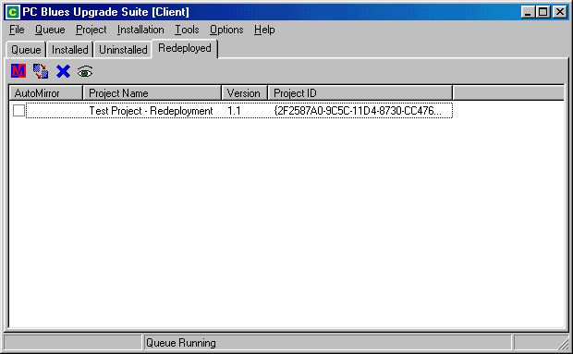

Other Functions of Upgrade Suite Client

Browse through Reference – Upgrade Suite Client to learn about more of the functionality of Upgrade Suite Client.

Upgrade Suite Server Manual [Server Only]
The Upgrade Suite Server enables you to generate Project Definition Files, generate patches and distribute files locally or to remote servers so that your users/clients can access the latest version of the your software and data.

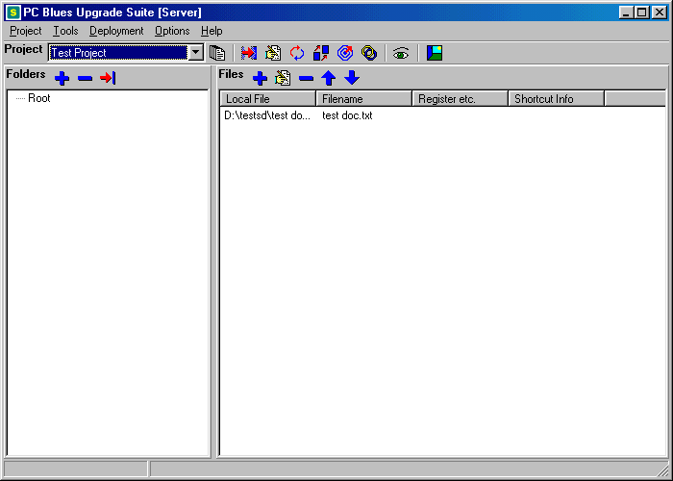

User Interface

The user interface is separated into three main areas with three toolbars: one for Project level operations, such as creation, deletion, editing and deployment; one for adding and removing folders from a Project; and, one for adding, removing, and configuring files in a Project.

Project Planning Considerations

This section will discuss various considerations to make when you are planning the deployment of a Project. Virtually any configuration of options will produce a working Project, but you can optimize the performance of the Server, Client¸ and Transmitter software for your own particular requirements and the performance of your computers and network connections.

What network permissions do my users and I need for my Project?

Depending on the type of Project you are creating, and whether the Project is going to be deployed on a local directory, a network, or an internet server, your specific requirements for access are going to vary. Basically, this is the usual requirements for most types of Projects:

Upgrade Suite Server
- Read / Write / Rename / Delete access for files under the Project’s Deployment Directory, and in it’s subdirectories.
- Read / List Files / Create / Delete access for directories and subdirectories of the Project’s Deployment Directory.

Upgrade Suite Client
- Read access for files under the Project’s Deployment Directory, and in it’s subdirectories.
- Read / List Files access for directories and subdirectories of the Project’s Deployment Directory.

How can I implement a Project efficiently?

There are certain types of files that will not save bandwidth or time from using the patching facilities of Upgrade Suite. For these types of files, you may want to turn off patching for that particular file, but it is not necessary ( see Reference – Upgrade Suite Server – Edit File in Project).

Files of this type include:

- Files larger than 10MB (unless you have plenty of time or a fast computer)
- Compressed files, which include most database, graphic, sound and video files

An alternative is to set the Project’s Upgrade Depth to 0 ( see Reference – Project Wizard – Project Preparation Settings)

Files cannot be larger than 500MB. At present, you need a fairly fast computer to patch files greater than 500KB in a reasonable amount of time. If you have an Upgrade Depth of more than three, and patches need to be made of many large files, the Preparation time could be very long indeed.

If you want to include in your Project an archive file or self-extracting archive that you have already created ( for example, with WinZip), store the files in the archive with NO compression before you add them to the Project. This allows Upgrade Suite Server to do the following:

1. Be able to compress the file effectively before it deploys it.
2. Be able to generate efficient patches for new versions of your archive files.

Can I deploy a file in a Project to a location other than the Deployment Directory?

Files in a single project are normally retrieved by the Client from the Client Deployment Path of a Project ( see Reference – Project Wizard – Project Preparation Settings ). But they can be deployed to, and accessed from, a different location than that specified in the Client Deployment Path.

This is done by editing the file ( see Reference – Upgrade Suite Server – Edit File in Project) and entering the full network path or URL before the file name in the Deployment File setting. There are a few points to consider if you are going to do this:

- The Server must have read/write access, and the Client must have at least read access to the Deployment Area of each file configured this way.
- The method of access for the file from the Server and Client will be the same – whereas, for example, normally you would be able to deploy your Project’s files using FTP, and the Client can use HTTP to retrieve them.
- Files can only be downloaded from a maximum of one FTP server per Project. Therefore, if you are using an FTP server for your Project’s Client Deployment Path, you cannot configure a single file in the Project to use a different FTP server.

Are there Directory and File Names I should avoid using in a Project?

You may experience problems if more than one directory in your project has the same name as another directory in the same Project.

It is important to note that the Upgrade Suite reserves certain file name extensions and
directory names for internal program use. It is unwise to use these as filenames and directory
names in your Projects. They may work, but they may also cause problems. This is the list:

Files and directories called "error"

Directories called “Windows” or “System” that are not meant to specifically contain files bound for a Target Computer’s own special Windows or Windows System directories ( see Reference – Folder Wizard )

Files with extensions of:
.dep
.dzp
.pbu
.rdp
.ser
.upg
.www
.xxx
.yyy
.zzz

Are there types of files I should avoid including in a Project?

If you are deploying an application with files that are going to be modified by the user or the application, you should not include them in the Project.

The reason for this is that once they are modified by the user or the application, Upgrade Suite will detect that they are not the latest version of the file when it is checking the status of the Project’s installation, or upgrading the Project. This will result in the modified file being replaced with the latest version of the file from the Project’s Deployment Area.

Instead, particularly in the case of files which contain saved program settings (e.g. ini files), make the application create them when it is first executed.

Can I create updates of software installed using another method?

Yes. Applications installed through commonly used installation programs can be upgraded with the Upgrade Suite. To make things easier for your user, it is a good idea to make the Default Installation Folder the same as the default installation folder in that application's installation program. This will minimize confusion for the user.

Otherwise, the user MUST select the correct folder that they installed the program to originally in order to update it, or the application will be installed twice on their computer.

How do I do this?

This is a brief description of how to create an update for software that was previously distributed using a different installation method (e.g. InstallShield or WISE) . You should have a firm grasp of the operations of Upgrade Suite Server before you do this. In any case, it may take some trial and error to get it right.

- Create a Project and import the file structure of the installation directory of the old version of the software.
- Add any Windows and System files required.
- Prepare the Project
- Deploy the Project to Null (see Reference – Upgrade Suite Server – Deploy Project to Null)
- Install the new version of the software into the original installation directory
- Add any new files to the Project that was not in the original version
- Prepare the Project
- Deploy the Project to your Deployment Area for the Project.

The files that were deployed to the Deployment Area will only be the files that had changed between the old and new versions of the software. You can now use the old installation media combined with the Project to install the latest version of the software on a client’s PC. Alternatively, you can upgrade an old version of their software without having to totally install a new version.

Creating and Editing a Project

When you create a new project ( see Reference – Upgrade Suite Server – Create Project ), you are prompted whether to start with a clean slate, or use the details of an existing open project if there is one open. In either case, a new Project ID is assigned. This uniquely identifies the new Project to the Upgrade Suite Client.

The user is then prompted for a name for the Project (e.g. Chip Analysis Software ), and a filename for the Project Definition File.

The user is prompted whether they want to import a directory structure into the Project. This is the quickest and easiest way to generate a distribution of software. Put all the files you require into a directory on your local machine and Import it into the Project. This will set the Source Directory for the Project. Importing files can be done later at any time of a Project, however the folder containing the files you wish to import must be the Project’s Source Directory or a subdirectory under that folder.

The Project Wizard is then displayed ( see Reference – Project Wizard ).

The Project General Settings screen of the Project Wizard can be printed out by clicking Print Form. It will print to your default printer. This is so that you have a hard copy of your Project’s Project ID Number. It is a very important number, and worth keeping ,because it is the only way that Target Computers can identify a Project. If you need to rebuild a Project , the Upgrade Suite Client will think that the replacement Project is the same.

See Reference – Project Wizard for more information on how to edit a Project.

Adding and Editing Project Folders

Folders can be added to a Project by using the Folder Wizard ( see Reference – Upgrade Suite Server – Add Folder to Project ).

Can I Import Files and Directories Straight into a Project?

You can use the Import Folder function to do this (see Reference – Upgrade Suite Server – Import Folder to Project)

Adding and Editing Project Files

To add a file to a Project, see Reference – Upgrade Suite Server – Add File to Project.

To edit an existing file in a Project, see Reference – Upgrade Suite Server – Edit File in Project.

Preparing a Project

See Reference – Upgrade Suite Server – Prepare Project.

Preparing a Project generates an image of the Project in the Project’s Staging Area that can be Deployed by Upgrade Suite. It also creates patches for previous versions of your Project's files depending on the Upgrade Depth of the Project.

A Project must have the following information in order to be Prepared:

- Project ID
- Project Name
- Source Directory
- Default Target Directory
- Project Filename
- Deployment Directory
- Client Deployment Path

The following Project information is optional, but recommended:

- Version number
- Main File
- Readme File
- Project Administrator Website
- Project Administrator Email

Testing a Project

This is not a mandatory step in the deployment of a Project.

In order to test the integrity of a distribution that could take a long time to upload to the Deployment Area (for example, if a modem connects the Source Computer to the Deployment Area), this function deploys the Project to a local directory for testing purposes with the Upgrade Suite Client.

The purpose of the Testing function is to allow you to Prepare and Deploy a copy of a Project without affecting the settings and status of the original Project.

See Reference – Upgrade Suite Server – Test Project

Deploying a Project

A Project must be Prepared at least once before it can be Deployed.

Deploying a Project invokes the Upgrade Suite Transmitter which performs the tasks of copying and uploading files from a Project’s Staging Area to it’s Deployment Area. It also deletes files and creates and deletes directories in the Deployment Area.

The behaviour of the Upgrade Suite Transmitter can be controlled from the Upgrade Suite Server (see Reference – Upgrade Suite Server – Edit Transmitter Settings)

See Reference – Upgrade Suite Transmitter for information about the operation of this component of Upgrade Suite.

In the case of Internet or intranet based deployment of a Project, an HTML link to a distribution of Upgrade Suite Client should be visible on the same page as the HTML link to the Project Definition File.

It is a good idea in intranet based deployments, to make the link point to a copy of the Upgrade Suite Client installation on a local server.

Directory Names on case-sensitive file servers

Some FTP servers are not case sensitive. You may get an error during deployment stating that you can't create a directory. Upgrade Suite Transmitter will try to create a directory on an FTP server if it believes that it doesn’t currently exist.

This can occur if it can’t “see” the directory on the FTP server (i.e. with Microsoft FTP servers, a directory called 'Fldr' will be detectable by looking for 'FLDR' or 'fldr', but in Unix based FTP servers, if you look for a directory called 'Fldr', then there may be a folder existing called 'fldr' that Upgrade Suite Transmitter will not see) This probably will not cause any problem, because the directory is there anyway, but it is good to be aware of it, especially because Windows 95 and Windows 98 sometimes change the case of newly named directories in Windows Explorer.

Special Technical Tip
If you are using an FTP server that you absolutely cannot get directory listing access rights to, there is an option you can try in order to deploy a Project.

The registry setting “HKEY_LOCAL_MACHINE/Software/Deploysoft/Upgrade Suite/Config/uselistcommand” can be set to false to avoid using the FTP directory list command. There is no technical support for this option, and it is not guaranteed to work.

The Upgrade Suite will assume that files are on the server in a particual place for the purpose of attempting to upload, download and delete them.

Managing the Deployment of Files

Each Project has a Deployment List, which is a list of files of which the latest versions have not yet been deployed successfully to the Project’s Deployment Area.

Depending on the Upgrade Suite Transmitter settings (see Reference – Transmitter Settings) the Deployment List is edited and used to determine whether a file is to be deployed to a Project’s Deployment area or not.

If the Upgrade Suite Transmitter is not set to “Deploy All Files”, it will only deploy files that are listed in the Deployment List. When it successfully deploys a file from the Staging Area to the Deployment Area of a Project, it will remove the file from this list.

Files are added to a Project’s Deployment List during Preparation when Upgrade Suite creates a new patch, or copies a new version of a Project’s file from the Source Directory to a Project’s Staging Area.

See the following references for more information about Deployment List functions:
Reference – Upgrade Suite Server – Clear Deployment List
Reference – Upgrade Suite Server – Edit Deployment List
Reference – Upgrade Suite Server – Populate Deployment List
Reference – Upgrade Suite Server – View Deployment List

Publishing Project Links

See Reference – Upgrade Suite Server – Publishing a Project

Pulling Down a Project

See Reference – Upgrade Suite Server – Pull Down Project

Deletes all the files that have been copied/uploaded to the Project’s Deployment Area. Upgrade Suite Transmitter is invoked to perform this task.

If during the Pulling Down of a Project, the Upgrade Suite Transmitter prompts you to remove all files from a directory called “/” or “\”, make sure this is what you want to do before you click “Yes”, or you may lose all files in the root directory of a file server or hard disk.

Other Functions of Upgrade Suite Server

Browse through Reference – Upgrade Suite Server to learn about more of the functionality of Upgrade Suite Server.

Upgrade Suite Transmitter Manual

The Upgrade Suite Transmitter is a program that is called by the Server and Client programs to deploy files to, and remove files from, the Deployment Area of a Project. It is not designed to be run on it’s own.

When the Upgrade Suite Transmitter is launched an icon will be displayed in the System Tray next to the clock. Right clicking on this icon will give you the option to show, hide, and exit Upgrade Suite Transmitter. Double-clicking on this icon will bring Upgrade Suite Transmitter to the front of your screen.

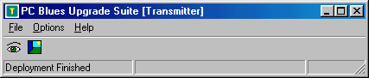

See Reference – Upgrade Suite Transmitter for more information about the features of the Upgrade Suite Transmitter.

Upgrade Suite Distribution Manager Manual [Server Only]
The Upgrade Suite Distribution Manager is a program that allows you to create, edit and delete Target ID’s for inclusion in a Project. If a Project includes any Target ID’s, only Upgrade Suite Client’s with any of the Target ID’s registered will be able to install or upgrade the Project. Target ID’s are referred to in Upgrade Suite Client as “Client ID”s.

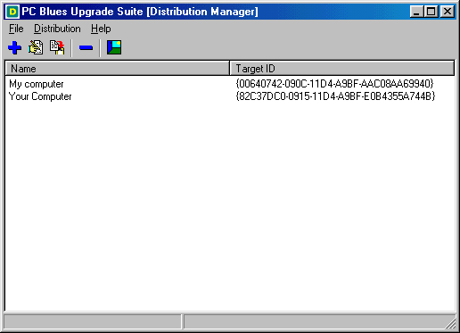

See Reference – Upgrade Suite Distribution Manager for a description of the functions of the Distribution Manager.

Reference

Upgrade Suite Client

Back Up a Project
Installation >> Back Up

Backs up the selected Project. You can back up a Project even it is not the latest version available, but it has to be fully installed. If it is not installed, or only partially installed, you cannot back it up. If you have backed up a Project, you can revert it to the backed up version if an upgraded version is faulty for some reason ( Installation >> Revert ).

Check a Project’s Installation
Project >> Check

Checks each of the files in the Project to see if it is installed, and if it is the latest version. If the Upgrade Suite Client is not in “silent mode” the user will be prompted to get the latest version of the Project Definition File before it performs the check. If the Upgrade Suite Client is in “silent mode”, it will attempt to get the latest version of the Project Definition File before performing the check. The actual location of this file is stored within the Project Definition File currently registered in Upgrade Suite Client.

The results of the check are displayed in the log, and the Project’s version, version status, and installation status are updated.

Clear Staging Area of a Redeployment
Installation >> Clear Staging Area

A Redeployment is the equivalent of a Project that has been created and deployed in the Upgrade Suite Server. Therefore, when an installed Project is redeployed, it copies the files from the installation directory of the Project to the Redeployment’s Staging Area to prepare patches and maintain previous versions of the original Project’s files if the Redeployment has been set up that way.

The Staging Area of a Redeployment can be cleared if you want to redeploy an installed Project, and remove the patches that have been created.

Clear Working Area of a Project
Installation >> Clear Working Area

Clears a Project’s Working Area, which is a subdirectory under the installation directory of the Upgrade Suite Client ( one for each Project) that is used to collect the files and patches from the Target Directory and the Deployment Area and combine them to create the latest versions of files for the Project whenever it is installed or upgraded.

Edit Internet Settings
Options >> Internet Settings

Loads the Internet Settings screen (see Reference – Internet Settings).

Edit Preferences
Options >> Preferences

Loads the Client Preferences screen ( see Reference – Client Preferences).

Edit Transmitter Settings
Options >> Transmitter Settings

Loads the Transmitter Settings screen ( see Reference – Transmitter Settings).

Email Project’s Administrator
Project >> Administrator Email

If a Project has an email address for the Administrator of the Project, your default email client will be opened with a new mail message to the Administrator. Otherwise, Upgrade Suite Client will notify you of the Administrator’s email address.

Emergency Exit
File >> Emergency Exit

This is not meant to elicit panic. Sometimes FTP or HTTP functions can lock up Upgrade Suite Client depending on a variety of server and network conditions. If File >> Exit does not work, you can try File >> Emergency Exit. It will force shut the FTP and HTTP connections and force the application to close.

Execute a Project
Project >> Run

Then main file of the Project is executed. If it is a program, it will be run. If it is a file, then it will be launched with the associated application, if there is one. If a Project does not have a main file to execute, a Windows Explorer window will be opened to the directory into which the Project has been installed.

Exit Upgrade Suite Client
File >> Exit

This exits the Upgrade Suite Client. If you are in the middle of an FTP or HTTP operation, it may not successfully close down the connection to the server, and Upgrade Suite Client will remain open. If you still wish to close Upgrade Suite Client, you can try File >> Emergency Exit.

Install a Project
Project >> Install

Installs the selected Project. It checks each of the files in the Project and downloads or copy whatever is necessary to bring the Project in the Target Directory up to date with the files in the Deployment Area of the Project.

If Upgrade Suite Client is configured to do so, the user will be prompted to select an installation directory ( Target Directory ) for the Project, or use the default one.

Files can be configured in the Upgrade Suite Server to be executed when they are installed, to have shortcuts created for them in the Program Files section of the Windows Start Menu, or to be registered in Windows ( This is necessary for some DLL’s and other ActiveX objects ).

Launch File Saver
Tools >> File Saver

Launches the File Saver, which is a tool for protecting files in the Windows and System directory which are overwritten by files in a Project when it is installed. Sometimes, different versions of the same file can make other software on the computer malfunction, so this provides the option of restoring the old file. See section Reference - File Saver for more information.

Load Project Definition File
File >> Open Project Definition File

There are a number of ways you can receive a Project Definition File. You can download it from a website and save it to your hard drive, save it from an attachment in an email, or execute it from a directory somewhere on your network.

This function will allow you to open a Project Definition File and register it with Upgrade Suite Client. Once a Project is registered with Upgrade Suite Client, it can be installed and upgraded until it is “removed completely” from Upgrade Suite Client.

Move a Project down the Queue
Queue >> Down

Only one Project can be installed or upgraded at a time. When a Project is manually or automatically installed or upgraded, it is placed on the Project Queue. The Project Queue lists the Project’s in the order in which they are going to installed or upgraded. The user can change the order of this list by selecting a Project in the queue, and using the up and down buttons.

Move a Project up the Queue
Queue >> Up

Only one Project can be installed or upgraded at a time. When a Project is manually or automatically installed or upgraded, it is placed on the Project Queue. The Project Queue lists the Project’s in the order in which they are going to installed or upgraded. The user can change the order of this list by selecting a Project in the queue, and using the up and down buttons.

Pull Down a Redeployment
Installation >> Pull Down

Similarly to a Project in the Upgrade Suite Server, a redeployed Project can be Pulled Down from it’s Deployment Area. This makes it unavailable to other computers with Upgrade Suite Client from upgrading or installing the Redeployment.

Redeploy a Project
Installation >> Redeploy

An installed Project can be redeployed to a new Deployment Area. This is discussed more in Reference – Upgrade Suite Client Manual – Redeploy a Project. The user can change the Administrator Email and Website settings. It is an ideal way for a network administrator to be in charge of the deployment of software on a local network that has been retrieved from the Internet.

In Upgrade Suite Client, the Remote Directory field must be filled when you Redeploy a Project.

Refresh a Redeployment
Installation >> Refresh

Refreshing a Redeployment is the equivalent of Preparing and Deploying a Project in Upgrade Suite Server. If an installation of a Project in Upgrade Suite Client has been upgraded since it was redeployed, the Refresh operation will copy new versions of files ( and created patches if configured to) to the redeployed Project’s Deployment Area.

Refresh Display
Tools >> Refresh Display

Reloads the details of Projects in each of the four Project lists in the Upgrade Suite Client ( Queue, Installed Projects, Uninstalled Projects, and Redeployed Projects ).

Remove a Project Completely
Installation >> Remove Completely

Removing a Project completely will remove all traces of the Project from the Upgrade Suite Client. If the Project is installed, it will be uninstalled. The Project’s Working Area will be deleted. If the Project has been Backed Up, then the Back Up will be deleted. The Project will then be unregistered from Upgrade Suite Client, and will no longer be able to upgraded until it is registered and installed again.

This option is not visible if Upgrade Suite Client is set to show the simple interface. You can also right-click on a Project and select Remove Completely.

Remove a Redeployment Completely
Installation >> Remove Completely

This will completely remove a redeployed Project and unregister it from Upgrade Suite Server. It will also Pull Down the Redeployment, and clear out the Redeployment’s Staging Area. Other computers which have installed the Redeployment will no longer be able to upgrade it. Other computers which have not installed the Redeployment will no longer be able to.

Remove a Project from the Queue
Queue >> Remove

If a Project in the Queue is not currently being installed or upgraded, it can be removed from the Queue. This does not uninstall or unregister the Project with Upgrade Suite Client, and the Project can be added to the Queue later by manually upgrading or installing it, or automatically by the Client if it is configured to do so.

Remove Back Up of a Project
Installation >> Remove Back Up

This will probably only be needed if you want to free up some hard drive space on the computer running the Upgrade Suite Client. If a Project has been Backed Up, this function will delete the back up files. A Project without a back up cannot be reverted to a previous version if an upgrade is faulty.

Roll Back Project to Previous Version
Installation >> Roll Back

A Project can be Rolled Back to the previous installed version if it has been Backed Up. Reasons you may wish to do this include if a new version of a software package contains new bugs, or is incompatible with other software on the computer.

Set Project Installation Directory
Tools >> Set Install Directory

If you want to change the installation directory of an installed Project, you can uninstall it, use this function to change the installation directory, and then re-install the Project. Any future upgrades will then be made to the Project in it’s new installation directory.

Show Hint Boxes
Help >> Show Hint Boxes

Most of the screens in Upgrade Suite have a hint box that can be activated by turning this option on. When you drag your mouse over elements of that screen, often there will be hints associated with that element of the user interface that automatically appear in the hint box. It can be turned off again by selecting Help >> Show Hint Boxes again.

Start the Queue
Queue >> Start

When the queue is started, Projects are taken off it one by one from the top down, and installed, or upgraded. There can only be one queue entry per Project.

Stop the Queue
Queue >> Stop

When the queue is stopped, Upgrade Suite Client will not process any installations or upgrades. If a Project is set to be automatically installed or upgraded, it will be added to the queue and it will be processed in due course when the queue is started again.

Uninstall a Project
Installation >> Uninstall

Uninstalling a Project will remove all the Project’s files from the installation directory, and from the Windows and Windows System directory if any files were installed there. If you want to reinstall a Project, you can do so without downloading any files from a network, or the internet, if you haven’t deleted the Project’s Working Area. The Working Area holds the latest version of all the Project’s files.

Upgrade a Project
Project >> Upgrade

Upgrading an installed Project will perform the following functions: retrieve the latest Project Definition File from the Deployment Area; check the installation status of the files in the Project, to see if any need updating or replacing; and, if so, queue the Project for upgrading.

View a Project’s Readme File
Project >> Readme

If a Project has a readme file, it will be displayed.

Depending on the type of readme file, an associated application will be launched to display the file. If there is no associated application for the file, Upgrade Suite Client will try to open the readme file in Windows Notepad.

View Latest Version of Project’s Readme File
Project >> Latest Readme

If the selected Project has a readme file, the latest version of it will be retrieved from the Project’s Deployment Area. This gives you an opportunity to review the new features and bug fixes in a new version of a Project, and decide if you want to upgrade your current installed version. The readme file of a Project can be retrieved from the Deployment Area before you install the Project, so you can review a Project without having to install it. The readme file will be executed when it has been retrieved.

Depending on the type of readme file, an associated application will be launched to display the file. If there is no associated application for the file, Upgrade Suite Client will try to open the readme file in Windows Notepad.

View About Screen
Help >> About Upgrade Suite Client

Displays the software name, version, build number, and copyright information. If you are contacting Customer Support with a problem, quote the software name, version and build number in your email.

View Log
Tools >> Show Log

Displays the log that is being kept of Upgrade Suite Client’s actions. See section Reference – The Log Screen for more information about how to understand, save and print the log.

View Online Help
Help >> Upgrade Suite Client Help

Opens the Upgrade Suite Client help file. You can also press F1 at any time and if there is a help topic specific to the area of Upgrade Suite you are in, it will be displayed, otherwise, the main help file will be displayed.

View Project Definition File
Tools >> View Project Definition File

Loads the selected Project’s Project Definition File into the log and displays it. You may need to scroll to the bottom of the log if other activities have taken place that would also be recorded in the log.

Visit Project Administrator’s Website
Project >> Administrator Website

If a Project has a website for the Administrator of the Project, your default web browser will be opened and you will be taken to the website. Otherwise, Upgrade Suite Client will notify you of the Administrator’s website address.

Visit Customer Support Website
Help >> Online Customer Support

Opens the computer’s default web browser and goes to the PC Blues customer support website (http://www.pcblues.com/support)

Visit PC Blues Website
Help >> Go to PC Blues Website

Opens the computer’s default web browser and goes to the PC Blues website (http://www.pcblues.com)

Client Preferences

The Client Preferences screen can be accessed from Options menu on the Upgrade Suite Client main screen. Most of the behaviour of the Client can be controlled from this screen.

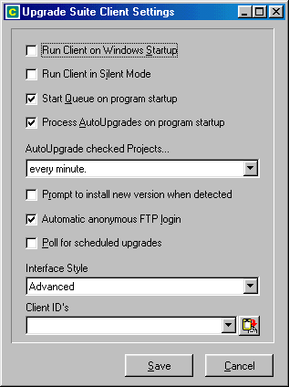

Run Client on Windows Startup

When selected, this option makes the Client execute when Windows is restarted, or when you turn on your computer.

Run Client in Silent Mode

When selected, messages and options that would normally be displayed to the user are suppressed. This means that there are a set of default actions that Upgrade Suite Client will take in the event of particular situations taking place. Errors and warnings will not be displayed except for exceptionally important error messages. This is the ideal mode for automating the installation and upgrading of software on user computers, but when you are testing a deployed Project, you will want to turn this off.

Start Queue on Program Startup

If you want the Client to automatically process the queue once Upgrade Suite Client is run, then select this option. De-selecting this option gives you more control over the installation and upgrading of installed Projects.

Process AutoUpgrades on Program Startup

Projects that have been checked to be AutoUpgraded are checked to see if they have the latest version of the Project installed, and, if there is a new version available, they are added to the queue to be upgraded.

AutoUpgrade checked Projects…

If Projects have been selected to AutoUpgrade, each time a certain period of time passes, the Projects are checked to see if they have the latest version installed. If not, the Projects are added to the queue to be upgraded. There are three time periods to choose from, or select “manually” to turn off the timed checking of AutoUpgraded Projects. Note that the option to “Process AutoUpgrades on Program Startup” will still work even if this setting is set to “manually”.

Prompt to Install New Version When Detected

If this is checked, when Upgrade Suite Client detects a new version of a Project is available, the user will be prompted whether or not to download and install the new version. This will not occur if Upgrade Suite Client is set to run in silent mode.

Automatic Anonymous FTP Login

If a Project needs to access an FTP server to get files from the Project’s Deployment Area, you will be prompted to enter a login name and password, unless this option is set. If this option is set, Upgrade Suite Client will try to access the FTP server using an anonymous login.

Poll For Scheduled Upgrades

If this option is checked, Projects which are scheduled to be installed or upgraded at a certain time will be checked every hour.

Interface Style

Choose from Simple or Advanced. Simple mode makes many of the toolbar buttons and menu options unavailable. It also hides the Redeployment tab. Most of the functions can still be accessed with the right-click menu while the mouse is over the list of installed or uninstalled Projects.

Client ID’s

You can paste new Client ID’s from the clipboard into here by clicking on the Paste button.

For more information about Client ID’s and how they are used in Upgrade Suite, see the sections Upgrade Suite Distribution Manager Manual, and Reference – Project Wizard – Project Distribution Targets.

File Saver

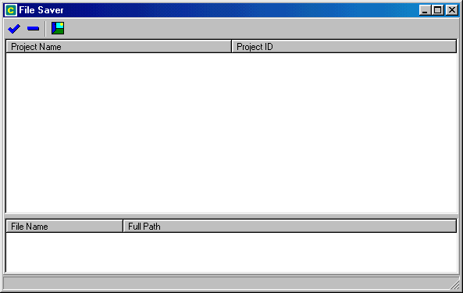
When Upgrade Suite Client copies files into the Windows or Windows System directories, if a file of the same name already exists there, the old version of the file is copied into the File Saver. If another piece of software installed on the system fails to operate after, for example, one of it’s DLL’s has been overwritten by a file in a Project, it can be retrieved.

The File Saver works in a similar way to the Recycle Bin on the Windows Desktop.

Restore File

Click on the name of the Project whose installation or upgrade has caused the problem. The files which were installed in the Windows or System directories will be displayed in a list at the bottom of the File Saver screen.

Highlight the file which you want to restore, and click Restore File.

Delete File

Files can be deleted from the File Saver’s file repository by selecting the file and clicking Delete File. This does not delete the file from the Windows or System directory, but deletes the file from the File Saver’s directory.

Exit File Saver

This closes the File Saver and returns you to the Upgrade Suite Client.

Upgrade Suite Server [Server Only]

Add File to Project
( Files Toolbar )

Select the folder you want to add a file into from the list under the Folders toolbar, and click the Add File icon in the File toolbar.

When you add or edit a file in a Project, the File Wizard will be displayed ( see Reference – File Wizard) It is a good idea to copy files to your source directory before you add them to your Project.

Add Folder to Project
( Folders Toolbar )

In the Folders Toolbar, click on this button to invoke the Folder Wizard (see Reference – Folder Wizard), to add a folder to the currently open Project.

Clear Deployment List
Deployment >> Clear Deployment List

Clears the Deployment List of the open Project. This has the effect of making Upgrade Suite Transmitter believe that the latest of all it’s files have been deployed successfully to the Project’s Deployment Area.

Clear Project Staging Area
Project >> Clear Project Staging Area

Deletes all the files in a Project’s Staging Area. This has the effect of clearing all the patches that have been made to a Project. When a Project is next Prepared, the latest version of the Project’s files are copied to the Staging Area, ready to be deployed to the Deployment Area.

Create Project
Project >> New Project

Creates a new Project and prompts the user to enter a name and a filename for the Project. The user is then prompted to import a directory structure into the Project. If a Project is already open when a new Project is created, the user will be able to keep the currently open Project’s details, and assign it a new Project ID, Project name, and Project filename.

The Project Wizard is then displayed. You must complete this wizard for a Project to be successfully set up. When you click the Next button, you will be notified if any mandatory information needs to be filled in.

Delete File from Project
( Files Toolbar )

Deletes a file from the current Project. It doesn’t delete the actual file from the hard disk, but when the Project is Prepared and Deployed, this file will be ignored.

If you unintentionally delete a file, you can click on Project >> Undo Project Edit to undo the deletion.

Delete Folder from Project
( Folders Toolbar )

Deletes a folder from the Project and any files under that folder. It does not delete the actual folder and files from the Project Source Directory. It only deletes the Project’s references to them, so that they will not be included in the Project when you Prepare and Deploy it.

If you unintentionally delete a folder, you can click on Project >> Undo Project Edit to undo the deletion.

You cannot delete the Root folder of a Project.

Delete Project
Project >> Delete Project

Deletes a Project from the Upgrade Suite Server. Firstly, the Project will be Pulled Down, by invoking the Upgrade Suite Transmitter. Next, it will delete the Project Definition File. Finally, it will delete the Project’s Staging Area. The files in the Project’s Source Directory will not be deleted.

When a project is deleted, it no longer appears in the Project List. Once a project is deleted, if the Project ID is not saved, no-one will be able to upgrade that Project on their computers again.

If there are a lot of subfolders and/or files in a Project, the Delete command may take a several minutes to complete.

Deploy Project
Tools >> Deploy

Deploys a Project to the Deployment Area. It invokes the Upgrade Suite Transmitter to do this. The Transmitter Settings ( Options >> Transmitter Settings ) determine the behaviour of the Transmitter upon being executed.

Deploy Project to Null
Tools >> Deploy to Null

Specifically, this function performs a deployment using the Upgrade Suite Transmitter, but does not actually transmit any files. This is useful for preparing a distribution that is made of patch files only.

Edit Deployment List
Deployment >> Edit Deployment List

This is an advanced function that loads the open Project’s Deployment List into Windows NotePad for editing and saving.

Edit File in Project
( Files Toolbar)

To edit the details of a file in a Project, click on a file in the file list, and select this function. Alternatively, you can double-click on the file in the list.

This function invokes the File Wizard ( see Reference – File Wizard ) to edit the details of a file in the open Project.

Edit Internet Settings
Options >> Internet Settings

Loads the Internet Settings Screen (see Reference – Internet Settings).

Edit Project
(Project Toolbar)
Project >> Edit Project

Loads the Project Wizard (see Reference – Project Wizard ).

Edit Transmitter Settings
Options >> Transmitter Settings

Loads the Transmitter Settings screen for determining the behaviour of the Upgrade Suite Transmitter when it is called from the Upgrade Suite Server.

See Reference – Transmitter Settings for important information about how the particular settings affect the behaviour of Upgrade Suite Transmitter.

Exit Upgrade Suite Server
Project >> Exit Upgrade Suite Server

Closes the Upgrade Suite Server.

Go to PC Blues Website
Help >> Go to PC Blues Website

Opens the computer’s default web browser and goes to the PC Blues website (http://www.pcblues.com)

Import Folder to Project

Importing a folder into a Project is the easiest way to add folders and files to a Project. When you import a folder, it will add the folder and any files in the folder to the Project.

A folder browsing dialog will be displayed for you to choose a directory to import into your Project. You can only select folders that are below the Project’s Source Directory. You will also be prompted whether to include subdirectories ( and the files in them) of the folder you choose to import into the Project.

Hidden files do not get imported by this function.

When importing folders, put files that you want to be installed into a Target Computer’s Windows or System directories in subfolders of the folder you are importing called “Windows” and “System” respectively. Upgrade Suite will copy files in these folders into the particular Windows and System folders on the Target Computer, no matter where they are located on the Target Computer’s hard disks.

When you create a new Project, you will be prompted to import a directory structure to the Project. The folder that you choose to import will be made the Project’s Source Directory.

Launch Upgrade Suite Client
Tools >> Run Client

Executes Upgrade Suite Client. Upgrade Suite Server will be minimized and unavailable until you exit the Upgrade Suite Client.

Launch Upgrade Suite Distribution Manager
Tools >> Run Distribution Manager

Executes Upgrade Suite Distribution Manager. Upgrade Suite Server will be minimized and unavailable until you exit the Distribution Manager.

Move File Down in Project Order
( Files Toolbar )

Moves a file in a Project down in the list of files in a Folder. This has an impact if the file is set to be executed when it is installed, because it enables the files above it to be correctly installed or upgraded before it if they are needed for the file to execute correctly.

Move File Up in Project Order
( Files Toolbar )

Moves a file in a Project up in the list of files in a Folder.

Populate Deployment List
Deployment >> Populate Deployment List

This will populate the Deployment List of a Project. This has the effect of making Upgrade Suite Transmitter think that all of the files in the Project need to be deployed to the Deployment Area of the Project. You may need to do this if you Pull Down a Project, don’t have the Upgrade Suite Transmitter set to “Deploy All Files”, and want to Deploy the Project again.

Prepare Project
Tools >> Prepare

When you have created a Project and incorporated files and folders into it, you are ready to Prepare the Project. This copies a Project’s files from the Source Directory to the Staging Area, and creates any patches necessary for the Project. You must do this before you Deploy the Project for the first time.

Publishing a Project
Tools >> Publish

After deploying a Project, you can publish a link to the Project as a windows shortcut, or an HTML link.

Upgrade Suite Server allows you to create a shortcut on your desktop which will point to the Project Definition File of the Project. If you configured the Project to be available on a Windows Network, Upgrade Suite will create a Windows Shortcut. If the Project is configured to be available on an HTTP of FTP server, an appropriate Internet Shortcut will be created. Note that some browsers will not execute FTP shortcuts correctly.

The desktop can take some time to refresh. If the shortcut has not appeared on the desktop, click once on any icon on the desktop and press F5. This is the command to refresh the contents of the desktop. This problem seems most pronounced on some Windows 98 computers.

You can email this shortcut to users who have access to the location of the Project’s Deployment Area, and they will be able to install the Project by double-clicking on the shortcut.

Alternatively, Upgrade Suite can copy some HTML linking to your Project on the Windows clipboard. You can paste this into your favourite HTML editor. If you have the “Include HTML Header and Footer Tags” option checked, the HTML that will be copied to the clipboard will consist of a complete web page that can be pasted into an empty file, and then edited to suit.

Pull Down Project
Project >> Pull Down Project

Removes a Project’s files from the Deployment Area, so that it is no longer available to computers with the Upgrade Suite Client. Computers which have already installed this Project will no longer be able to upgrade the Project, until it is deployed again.

Select Project

The Projects which have been created are listed in a drop down box on the Projects Toolbar. Select a Project from this list, and the currently open Project will be saved, and the newly selected Project opened.

Select Group of Projects

Displays a list of the Projects for you to select one or more of. When you close this list, the Select Group button will be depressed. When you Prepare or Deploy, this action will apply to all the Projects that you selected from the list. If you click on the Select Group button again, it will deactivate this feature, and the Prepare and Deploy actions will only apply to the open Project.

Show Hint Boxes
Help >> Show Hint Boxes

Most of the screens in Upgrade Suite have a hint box that can be activated by turning this option on. When you drag your mouse over elements of that screen, often there will be hints associated with that element of the user interface that automatically appear in the hint box. It can be turned off again by selecting Help >> Show Hint Boxes again.

Test Project
Tools >> Test

When you test a Project, a test version of the Project is created. This is a copy of your original Project.

You will be prompted to select the Deployment Directory for the test Project. If the default is adequate, or after you have edited it, click OK. You can deploy the test Project to an FTP server if you wish.

The test Project is then Prepared and Deployed to the test directory.

Upgrade Suite Client is then run, and you can test the installation of the Project. Once you exit from Upgrade Suite Client, the test Project is Pulled Down, and deleted by the Upgrade Suite Server.

You can remove the test Project from Upgrade Suite Client by removing it completely ( see Reference – Upgrade Suite Client – Remove a Project Completely )

Undo Project Changes
Project >> Undo Project Edit

If a file or folder is inadvertently deleted, you can use this feature to restore it. Also you can undo changes made to Projects, file or folders using the wizards. Note, though, that you can only undo one level of change.

View About Screen
Help >> About Upgrade Suite Server

Displays the software name, version, build number, and copyright information. If you are contacting Customer Support with a problem, quote the software name, version and build number in your email.

View Deployment List
Deployment >> View Deployment List

Displays the Deployment List of the open Project in the Log and displays the Log screen.

View Log
Tools >> Show Log

Displays the log that is being kept of Upgrade Suite Server’s actions. See section Reference – The Log Screen for more information about how to understand, save and print the log.

View Online Help
Help >> Upgrade Suite Server Help

Opens the Upgrade Suite Server help file. You can also press F1 at any time and if there is a help topic specific to the area of Upgrade Suite you are in, it will be displayed, otherwise, the main help file will be displayed.

View Project Definition File
Tools >> View Project Definition File

Loads the Project’s Project Definition File into the log and displays it. You may need to scroll to the bottom of the log if other activities have taken place that would also be recorded in the log.

Visit Customer Support Website
Help >> Online Customer Support

Opens the computer’s default web browser and goes to the PC Blues customer support website (http://www.pcblues.com/support)

Visit PC Blues Website
Help >> Go to PC Blues Website

Opens the computer’s default web browser and goes to the PC Blues website (http://www.pcblues.com)

Project Wizard [Server Only]

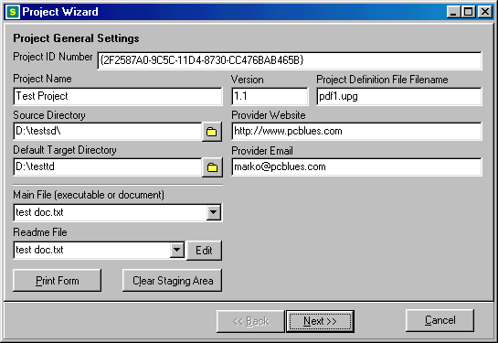
When you create or edit a new Project, the Project Wizard will be displayed. This lets you configure every aspect of a single Project, from where it will be deployed, to the number of different versions of updates Upgrade Suite will maintain for the files in the Project. It also gives you control over aspects of the Project which control the way the Upgrade Suite Client handles it. An example of this is setting a date before which the Upgrade Suite Client will not install or upgrade the Project.

The next part of this manual will take you through the different pages of the Project Wizard, describing how to create a Project and prepare it for distribution.

Project General Settings

Project ID Number
When you create a Project, it will be assigned a unique number which will distinguish it from all other Projects in the world. There is a 1 in 2^32 chance of another Project having the same ID Number – that is, about 1 in 4 billion. Do not edit this number unless you are re-creating a Project, and you want to copy in a previously created Project ID Number.
Note!
The Project ID is a very important number. The Upgrade Suite Client uses it to identify Projects. Therefore, it must be protected for the expected life-time of a Project. It is a good idea to print this number out, or make sure the installation directory of Upgrade Suite is regularly backed up.

Project Name
This is the plain language name of your Project. This is the name by which the Upgrade Suite Client will know this Project. When you publish the Project (see Reference – Upgrade Suite Server – Publishing a Project ) you will be creating HTML or a Windows Shortcut to the Project. Make sure the Project Name contains no special characters, such as *, \ or /, because this will cause errors later on.

Version
This is optional, but a version number is useful for users of the Upgrade Suite Client. The Client displays the currently installed version of a Project, and also displays the version number of an available update. The Client does not require different version numbers for a new upgrade of a Project, but it makes more sense to the user.

If you do not change the version number while preparing an upgrade of a Project, the Client will report that a new version is available, but it will also report something like “Version 1.1 installed, Version 1.1 available”

Project Definition File Filename
The Project Definition File is stored using this name. This file gets deployed with the Project. For web-based deployment to a public access web server, this file could be loaded into Upgrade Suite Client anywhere in the world with an internet connection, and the file would contain enough information to install, or upgrade the Project on that computer. You could just email the small file to someone, or send it to them on a floppy disk. This is one of the features that makes Upgrade Suite a powerful tool.

Source Directory
This is the directory that contains the files you are deploying. You do not have to deploy all the files in this directory and it’s subdirectories. You can actually choose the files and directories to include in your Project or you can import a directory, it’s contents, and optionally the directories’ subdirectories and their contents. If you have files to be installed into the Windows or System directories on the Client’s computer, you put these in subdirectories of the Source Directory called Windows and System respectively. The Upgrade Suite Client will know that these files are to go into the special directories, wherever they are on the Client’s computer, and whatever they are called. The button to the right of the Source Directory box allows you to browse for the Source Directory.
Note!
You cannot include files into a Project that are above the level of the Source Directory. It represents the root directory of the installed files on the Client computer. However, you can change the way the subdirectories of the Source Directory are structured when the Project is installed on the Client Computer. See Folders Wizard for more details

Default Target Directory
This directory is where the Upgrade Suite Client will install the Project by default. Depending on the configuration of the Client, it may prompt the user with the option of installing the Project somewhere else. This will only be asked when the Project is being installed the first time. Upgrades and patches will be installed to the eventual installation directory of a Project on the Client computers. The button to the right of Default Target Directory box allows you to browse for a folder, but you will probably just want to type in the Default Target Directory.

Administrator Website
You can provide a website for the recipients of your Project to access for support or information. A button in the Upgrade Suite Client allows users to jump straight to your website if you have provided one here. Use the full name of the website you wish users of your Project to be able to access (e.g. http://www.pcblues.com )

Administrator Email
You can provide users of your Project with an easy way to email you through the Upgrade Suite Client. Enter your email address in the form someone@pcblues.com and they will be able to contact you by email by selecting your Project in the Client and clicking on a button.

Main File
After you have included files in your Project, you will be able to select a file to be your main file for the Project. This will be the file that executes or opens when a user chooses to run a Project in the Upgrade Suite Client. The file must be in the Source Directory of a Project. It cannot be in a subdirectory of the Source Directory.

Readme File
After you have included files in your Project, you will be able to select a file to be your readme file for the Project. This will be a file that opens when a user chooses to view the readme file of the Project in the Upgrade Suite Client. A very handy feature for users of the Client software is that they will be able to download and view the readme file without having to install the Project. You can provide information to a user that they can use to decide whether they want to download the Project for the first time, or if they need to upgrade their installed version of a Project to the latest one.

Print Form
This is a good idea when you create a Project. As mentioned in the description of the Project ID Number, the number is an important detail to keep record of. This function will print out this form to your default printer.

Clear Staging Area
There are several main holding areas for files used by Upgrade Suite. The Staging Area is one of them. This area is a found in a subdirectory of the Upgrade Suite’s installation directory. When a Project is Prepared, a Staging Area is set up for the Project if it does not already exist. This contains patches, and current and previous versions of the files in the Project. If you wish to clear out existing patches, and force your users to download a completely new version of your new and updated files in your Project, this function will do that for you.
Note!
Keep plenty of free disk space on the drive you have installed the Upgrade Suite. If you are deploying large Projects, and / or maintaining many versions of your Project, the Staging Area can become very large.

Project Transmission Settings

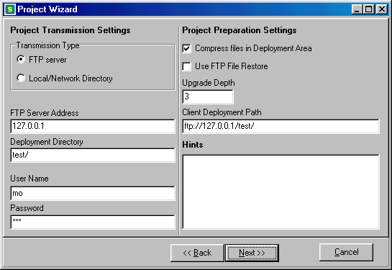

The first option to set is the Transmission Type. It is important to note that this is the method with which you will be deploying your Project, and may not necessarily be the way that Client computers retrieve the Project.

If you will be deploying your project to an FTP server using the FTP protocol, read the instructions under FTP Server below. If you are going to deploy your Project to a directory on the computer you are running Upgrade Suite Server, or in a directory on another computer in your Windows Network, read the instructions under Local/Network Directory.

FTP Server

FTP Server Address
Enter the address of the FTP server you will be deploying the Project to. You can use the English address (e.g. ftp.foo.bar ) or the numeric IP address (e.g. 120.120.230.1 ).

Deployment Directory
This is the directory on the FTP server in which you will deploying your Project.
Note!
It is not a very good idea not to use ‘/’ as your Deployment Directory. Under certain options, the Upgrade Suite will attempt to delete everything under the Deployment Directory, and this will attempt to delete EVERYTHING on your FTP server.

Remember that if the type of transmission is “FTP Server”, that the slashes are “/” for Unix FTP servers, and “\” for Windows servers.

With FTP accounts that allow anonymous access, often the directory that the anonymous user logs into is a subdirectory of the directory that the Upgrade Suite Server user logs into. Make sure during the editing of the project file that if anonymous FTP access is to be used by the Client for accessing a Project’s files, the Client Deployment Path contains the anonymous user’s path and the Deployment Directory has the path that the FTP account owner would see.

User Name
This is the user name to access the FTP server for deploying files.

Password
This is the password to access the FTP server for deploying files.

Local/Network Directory

When you select this method of transmission of your Project, the FTP Server Address, User Name, and Password settings are disabled. Note that you will need to have file write access to whichever directory you are going to be deploying the Project. Likewise, your potential users will need to have at least read access to the directories that you are deploying the Project to.

Deployment Directory
You can enter the Deployment Directory in a number of ways that Upgrade Suite will recognize. You can use any local or mapped network drives (e.g. g:\deployment area\my project ). You can also use UNC directory descriptions (e.g. \\MYSERVER\MYDIR )
Note!
It is a very good idea to give your Deployment Directory a definite own name. Under certain options, the Upgrade Suite will attempt to delete everything under the Deployment Directory, so everything that is in that directory and below will be deleted.

Remember to use “\” slashes.

Project Preparation Settings

Opposite the Project Transmission Settings are the Project Preparation Settings.

Compress Files in Deployment Area
If you check this option, all files that Upgrade Suite Server sends up to the Deployment Area will be compressed. This saves space in the Deployment Area, but lengthens the time to transmit the files. Keep this in mind if you are using a slow computer and dealing with large numbers of large files. The Upgrade Suite Transmitter is the program that actually compresses the files, so you will not notice the difference in performance until you Deploy the Project.

Use FTP File Restore
This setting allows the resumption of the download of a single file if it has been interrupted before it is completed. It is only valid if the Project and file has been set up to be retrieved by the Upgrade Suite Client from an FTP server. It will only work if the FTP server supports file resumption. Upgrade Suite Client will attempt to resume the download of that file from the point where it stopped. However, if the FTP server does not support resumption of downloads, Upgrade Suite Client will not function correctly.
Note!
You do not have to select this option to take advantage of all the other features of Upgrade Suite, such as repairing corrupt installations, and resuming the interrupted downloading of Projects. This option works on a single file only.

Upgrade Depth
The Upgrade Depth is a number that represents the number of versions of files in your Project that get archived and patched for deployment when a Project is Prepared. For example, consider a Project with an Upgrade Depth of 3. Imagine that it contains a readme file that you update each time you Prepare and Deploy the Project. In version 1, the full file is deployed to the Deployment Area. If a user of the Upgrade Suite Client installs this Project, they will get download this file as part of the installation. Then you Prepare and Deploy version 2. A patch will be created which contains the differences between the original readme file and the updated version. Likewise, when you Prepare and Deploy version 3, a patch will be created containing the differences between the original readme file and the version 3 file. A patch will also be created between the version 2 file and the version 3 file. This enables the Upgrade Suite Client to have either version 1 or version 2 installed, and only download one patch to upgrade the readme file to the latest version. Upgrade Suite automatically handles the preparation, patching, deployment and selection of the correct patch for all the files in a Project. Patching can be manually overridden for files in the Project if they are unsuitable for patching. See Upgrade Suite Server Manual - Project Planning Considerations for more information about patching.

Below you will find the effects of setting different Upgrade Depths for a Project. Select an Upgrade Depth that is appropriate for your Project.

0
No patches are made of files when Projects are Prepared. When the Upgrade Suite Client is upgrading an installed Project, if a new version of a file is available, then the full version of that file will be downloaded and installed.

1
If a file has changed since the last time the Project was Prepared, a patch for the previous version of the file will get created and stored in the Staging Area for each file in the Project. Only one patch per file is kept, so if users do not update their software before two Preparations of your Project that create a patch for a file, the Upgrade Suite Client will download the full new file to update the installation.

2 or more
You can make several updates to the files in your Project, Prepare and Deploy them, and your users can let their latest installed version of the Project lapse and still take advantage of only downloading patches that will bring their installed version of the Project up to date. Note, though, that depending on the Upgrade Depth that you nominate for a Project, there will be that number of copies of each file in the Project stored in the Staging Area, so that patches can be made of each of them to bring them up to date. For large numbers of files, and/or large files, this can use a lot of hard disk space, and also take a long time to Prepare and Deploy the Project. Bare this in mind when selecting the Upgrade Depth for a Project, and consider the size and number of files in the Project.

Client Deployment Path
This is the setting which determines how the Upgrade Suite Client retrieves and upgrades the Project. In comparison, the Project Transmission Settings determine how the Upgrade Suite Server deploys the files in a Project to the Deployment Area.

The Client Deployment Path can provide Upgrade Suite Client with a different method of retrieving the files than the way the Server deployed the Project. For example, you may deploy a Project to the Deployment area using an FTP connection, and the Client can retrieve the files using an HTTP address. This is similar to the way websites are usually uploaded to, and then browsed on the internet.

There are several ways the Client software can retrieve and install the files in a Project.For the following examples, suppose the Project has been deployed to a directory called “myproject”. To make a Project available from a web site, enter the web address of the directory containing the Project, e.g. http://www.web.com/myproject. If you want to make the Project available from an FTP server, use an FTP address, e.g. ftp://ftp.web.com/myproject. To make a Project available on a Windows Network, enter the network directory in which the Project resides, e.g. \\NETWORKSERVER\MYPROJECT. Or, if all your potential Client computers have a mapped network directory, you can use this, e.g. Z:\DIRECTORY\MYPROJECT.

Separate files in a Project can have the Client Deployment Path overridden. For example, you may want a documentation file to be retrieved from your website, while the rest of the files in a Project are obtained from a company’s intranet.

Project Scheduling

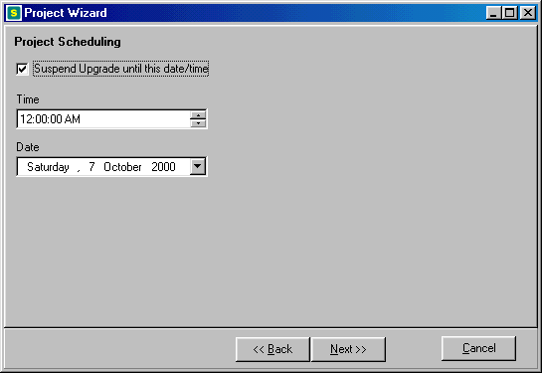

If you check Suspend Upgrade Until This Date/Time, you can force Clients to not allow an installation or an upgrade to occur before this date and time. The Upgrade Suite Client needs to have an option set to check for scheduled upgrades for this functionality to work. There are a few considerations to make when using this feature. If you to make a Project available to computers in different time zones, the Project will install at different times possibly to the one you intended. If you have to delay an installation of a Project or it’s upgrade, make sure you take this into account. One potential benefit of this feature is that if you deploy a Project to a web server, and have thousands of Client computers all around the world, the installation or upgrade will be staggered across a twenty four hour period, which will reduce the load on the web server containing the Deployment Area.

Project Dependencies

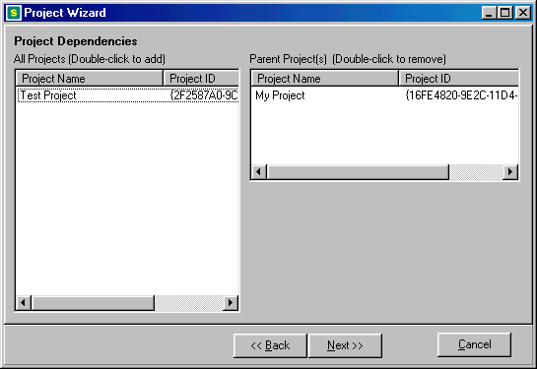

You can deploy Projects which require other Projects to be installed first. This enables the distribution of software components, which will only be installed if the main component(s) have been installed. The Upgrade Suite Client will not allow a Project to be installed if any of the Parent Projects that you specify have not been fully installed.

The names of all the Projects that you have created with Upgrade Suite Server will be listed in the left hand side of the screen. Double-click on any of these that you want to be installed on the Client before it will allow the installation of the current Project you are working on. Remove dependencies by double-clicking on them in the right hand list of Projects.

The Upgrade Suite Server will not allow you to make a Project it’s own Parent.

Project Distribution Targets

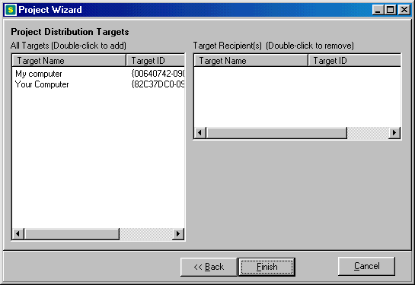

The Upgrade Suite Distribution Manager allows you to create and maintain Distribution Targets. These have a Target ID associated with them. Double-click on the targets in the left hand list to add them to the Project.

If a Project has one or more Distribution Targets, the Upgrade Suite Client will check that it has the Project’s Target ID in it’s own list of Client ID’s. If it does not, it will not allow the Project to be installed or upgraded. If a Project has no Distribution Targets, the Project will be allowed to install on any computer with Upgrade Suite Client.

See Reference – Client Preferences – Client ID’s for information about how to register Client ID’s with Upgrade Suite Client.

See Reference - Upgrade Suite Distribution Manager for information about how to create and manage Client ID’s.

Folder Wizard [Server Only]

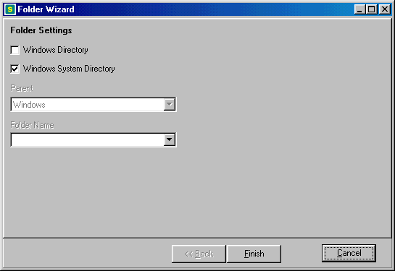

Adding folders to a Project will result in the Folder Settings wizard being displayed.
Note!
You cannot have a folder in your Project called “Windows” or “System”. These are special reserved folder names used for directories in the Source Directory that contain files which will be installed into the Windows and Windows System directories on the Target Computer.

There are two ways to add a folder to your Project using the Folder Wizard. You can create a subdirectory under your Project’s Source Directory using Windows Explorer, and then use the Folder Wizard to bring it into your Project. Or, you can enter the new folder’s name into the Folder Wizard, and Upgrade Suite Server will create the folder when you first add files to it.

To add a normal folder to your Project, select the Parent directory from the drop down list. Any subdirectories of the directory you select as the Parent will be displayed in the Folder Name drop down list. You can type the name of the directory to be added into the Folder Name box, or, if it already exists, select it from the list.

Upgrade Suite allows you to install files into a Target Computer’s Windows or Windows System directories. These are special directories on each comptuer that are determined by two factors: the directory Windows was originally installed to, and the version of Windows on the Target Computer. To add a Windows or System directory to your Project, check the appropriate checkbox and click Finish. Alternatively, you can create a folder in your Project’s Source Directory (using Windows Explorer) called Windows or System. Put all the files you want to install into their appropriate special folder, and then Import the directory into your Project. Upgrade Suite Server will recognize that it is a special folder.

When you add files to a folder in a Project, if the directory does not already exist in the Source Directory, Upgrade Suite will create it.

File Wizard [Server Only]

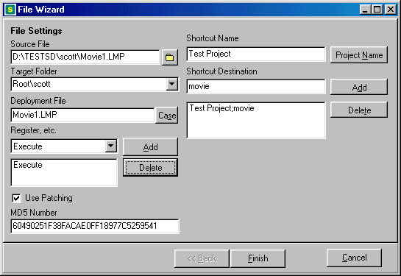

Source File
Note!
While you can add files to your Project without copying them to your Source Directory, it is a good idea to copy the files to the Source Directory before adding them to the Project. This gives you better control over the files, especially files that are to be installed to the Target Computer’s Windows or Windows System directories.
Click on this button to select a file to add to your Project. The file name (without the file path) will be entered into the Deployment File setting.

Target Folder
This displays the folder that the file will be installed into by the Upgrade Suite Client. The user cannot change this setting.

Deployment File
This is the name of the file as it will be deployed by Upgrade Suite Server and installed by Upgrade Suite Client.

You can change this name to a name that is different to the name of the source file, but only do this if you need to. It is better to rename the file in your Source Directory before adding it to the Project.

The “Case” button allows you to change the file name to all upper case or all lower case. There are several scenarios in which you may need to do this, but only if you have problems with your deployment.

Register, etc.
You can execute and/or register any file in your Project. Select whether you want to Execute or Register a file, and click the Add button. “Execute” will launch the file when it is installed by Upgrade Suite Client, and Register will register the file with Windows, which you need to do with some DLL files, and ActiveX objects.

This feature is useful if you want to execute a self-extracting archive on the Target Computer during the installation of a Project.

Actions can be removed from the list by selecting them in the list and clicking the “Delete” button.

Use Patching
Not all files are suitable to be patched. You can turn patching off for particular files. More information on a file’s suitability for patching can be found in Upgrade Suite Server Manual – Project Planning Considerations – How Can I Implement a Project Efficiently?

MD5 Number
This number is generated by Upgrade Suite Server after a file has been added to a Project, and cannot be edited by the user. It is used by the Upgrade Suite Client to determine if an installed file is the latest version.

Shortcut Name
You can create entries in the Start menu under the Programs section for a Project. Clicking on the Project Name button will make the shortcut’s name the same as the name of the Project. If appropriate, enter a Shortcut Destination in the setting box below, and click Add.

Shortcut Destination
If you want your shortcut to be in the Start menu directly under “Programs”, leave this blank. If you want to group shortcuts to different files in your project together in the Start menu, enter a Shortcut Destination here before you click Add. For example, if the Shortcut Name is “Run This”, and the Shortcut Destination is “Company”, you will be able to execute this file by clicking on Start >> Programs >> Company >> Run This.

File Action
When a file is set to be executed or registered with Windows, the action will occur as soon as it is installed. The action will occur whether or not the file needs to be upgraded when the Project is installed or upgraded.

Internet Settings

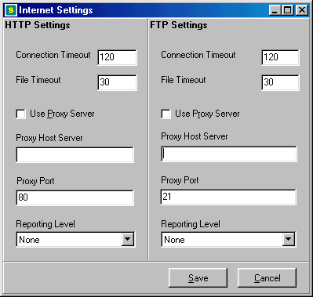

The Internet Settings screen allows you to configure FTP and HTTP settings for receiving files using the Upgrade Suite Client. By default, FTP uses port 21, and HTTP uses port 80, and these are not changeable. However, proxy hosts can have their port settings altered. Proxy servers are most often used in conjunction with firewalls. Consult with your System Administrator whether you need to set these, and if so, what the settings should be.

Connection Timeout
When an FTP or HTTP server is contacted to retrieve or send a file, the Client or Transmitter will wait for a connection for as long as the Connection Timeout (in seconds). If the server cannot be connected to in this time, the file transfer is considered to have failed.

File Timeout
When an FTP or HTTP server is sending or receiving a file, it is sent in chunks. If the time between chunks of a file is longer than the File Timeout, then the file transfer is considered to have failed.

Use Proxy Server
If this option is checked, files will be transferred using the proxy server settings below.

Proxy Host Server
This is the IP address (e.g. 124.124.124.20 ) or server address (e.g. proxy.yourhost.com ) of the proxy server.

Proxy Port
This is the number of the port that the proxy server uses to transmit files.

Reporting Level
When the Upgrade Suite Client is using FTP or HTTP protocols to send or retrieve files, messages are generated reporting the status of the file transfers. The level of detail reported in the log of the Client or Transmitter depends on the Reporting Level set by the user. In increasing levels of verbosity, these are the possible settings:

None
Informational
Basic
Routines
Debug
Trace

Transmitter Settings

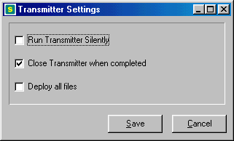

The Server uses the Upgrade Suite Transmitter program to Deploy and Pull Down Projects. The Transmitter Settings allow you to control how the Transmitter operates when it is called by the Server.

Run Transmitter Silently
The Transmitter program will run without prompting the user with messages or warnings. Checking this option will mean that even messages warning of a critical error to the redeployment or pulling down of a Project will not be displayed.

Close Transmitter when Completed
This will simply close the Transmitter program after it has finished executing. You will want to turn this option off while you are testing a Project, so that you will be able to view the log of the Transmitter’s operations after it has finished deploying a Project’s files, or removing them from a Project’s Deployment Area.

Deploy all files
This setting has important implications for your Project. It affects the actions that the Transmitter takes when it is deploying a Project’s files to the Deployment Area. It has no effect on Pulling Down a Project from it’s Deployment Area.

Effects when option is turned off:
When you deploy or redeploy a Project, no files will be deleted from the Deployment Area, and only new files and patches that have not yet been successfully deployed will be deployed.

Effects when option is turned on:
When a Project is deployed or redeployed, all the files and folders in the Deployment Area are deleted, and all files and patches are then uploaded to the Deployment Area from the Project’s Staging Area.

It is important to make sure that no important files exists in the directories that you do
specify to contain the Project.

The reason to delete all files in a directory before an entire new set of files are deployed is so
that files that may have been removed from a Project altogether get deleted from the Deployment Area.

Upgrade Suite Transmitter

Edit Internet Settings
Options >> Internet Settings

Loads the Internet Settings screen (see Reference – Internet Settings).

Emergency Exit
File >> Emergency Exit

This is not as meant to elicit panic. Sometimes FTP or HTTP functions can lock up Upgrade Suite Transmitter depending on a variety of server and network conditions. If File >> Exit does not work, you can try File >> Emergency Exit. It will force shut the FTP and HTTP connections and force the application to close.

Exit Upgrade Suite Transmitter
File >> Exit

This exits the Upgrade Suite Transmitter. If you are in the middle of an FTP or HTTP operation, it may not successfully close down the connection to the server, and Upgrade Suite Transmitter will remain open. If you still wish to close Upgrade Suite Transmitter, you can try File >> Emergency Exit.

Show Hint Boxes
Help >> Show Hint Boxes

Most of the screens in Upgrade Suite have a hint box that can be activated by turning this option on. When you drag your mouse over elements of that screen, often there will be hints associated with that element of the user interface that automatically appear in the hint box. It can be turned off again by selecting Help >> Show Hint Boxes again.

View About Screen
Help >> About Upgrade Suite Transmitter

Displays the software name, version, build number, and copyright information. If you are contacting Customer Support with a problem, quote the software name, version and build number in your email.

View Log
Tools >> Show Log

Displays the log that is being kept of Upgrade Suite Transmitter’s actions. See section Reference – The Log Screen for more information about how to understand, save and print the log.

View Online Help
Help >> Upgrade Suite Transmitter Help

Opens the Upgrade Suite Transmitter help file. You can also press F1 at any time and if there is a help topic specific to the area of Upgrade Suite you are in, it will be displayed, otherwise, the main help file will be displayed.

Upgrade Suite Distribution Manager [Server Only]

Add Target
Distribution >> Add

Creates a new Target ID, and prompts you to give it a name for your reference, and to use to include the Target ID in Projects ( see Upgrade Suite Server – Project Wizard – Project Distribution Targets )

Copy Target ID to Clipboard
Distribution >> Copy

Copies a Target’s Target ID to the clipboard. You can email this to potential users of Projects which have had the Target ID included in a Project. Alternatively, you can post the Target ID on a website too. In order for a user of Upgrade Suite Client to install a Project which has this Target ID included in it, they have to register the Target ID with Upgrade Suite Client ( see Reference - Client Preferences )

Delete Target
Distribution >> Delete

Deletes a Target from the Target list. Once a Target is deleted, it can no longer be added to Projects. If Projects no longer have this Target ID included in them, it is rendered inoperable in copies of Upgrade Suite Client which have it registered.

Edit Target
Distribution >> Edit

Allows you to edit the details of a Target. The Target ID is a unique number that should not be edited unless you know what you are doing.

Exit Distribution Manager
File >> Exit

This exits the Upgrade Suite Distribution Manager.

Show Hint Boxes
Help >> Show Hint Boxes

Most of the screens in Upgrade Suite have a hint box that can be activated by turning this option on. When you drag your mouse over elements of that screen, often there will be hints associated with that element of the user interface that automatically appear in the hint box. It can be turned off again by selecting Help >> Show Hint Boxes again.

View About Screen
Help >> About Upgrade Suite Distribution Manager

Displays the software name, version, build number, and copyright information. If you are contacting Customer Support with a problem, quote the software name, version and build number in your email.

View Online Help
Help >> Upgrade Suite Distribution Manager Help

Opens the Upgrade Suite Distribution Manager help file. You can also press F1 at any time and if there is a help topic specific to the area of Upgrade Suite you are in, it will be displayed, otherwise, the main help file will be displayed.

The Log Screen

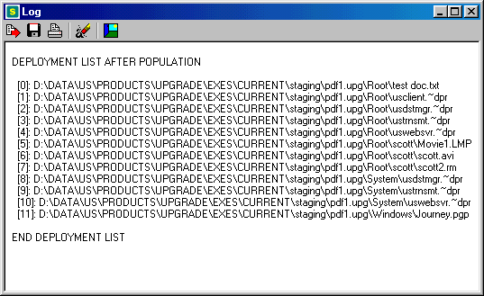

The Log screen displays a record of the activities of each of the components of Upgrade Suite. Each component of Upgrade Suite keeps it’s own log. Unless you save the log, it will be lost whenever you terminate a particular component of Upgrade Suite. Each time you save the log, it will overwrite any previously saved log for that particular component of Upgrade Suite.

Understanding the Log

Many operations are recorded in the log of each component of Upgrade Suite. The logs can be very useful in verifying the reasons for the failure of a Project’s deployment, installation, or upgrade.

HTTP and FTP operations are also logged on the Log Screen, depending on the level of detail that has been specified in the Internet Settings of a particular component of Upgrade Suite (see Reference – Internet Settings).

Understanding Deployment and Pull Down Results

a→ b - A file was successfully transferred from a to b.

a –x- b – A file was unsuccessfully transferred from a to b.

a –reboot-> b – A file was successfully transferred from a to b, but the file it was meant to replace could not be overwritten because it was in use or locked by the computer. When the user’s computer is rebooted, it will complete the file replacement.

-dep->
File has been converted to a deployable format and copied to the Staging Area of a Project ready for deployment.

The log also records file compression and patching operations. If a compressed version of a file is being transmitted to the Deployment Area of a Project, it will be suffixed with a (z) to indicate that it is compressed.

Toggle Word Wrap

Turns word wrapping on and off.

Save Log

Saves the log of the currently executing Upgrade Suite component to a text file. The name of the file will be displayed to the user.

Print Log

Prints the log to the default Windows printer.

Clear Log

Deletes any text in the log.

Exit Log

Exits the log. The contents of the log are not cleared.

Security
This section discusses the security aspects of using Upgrade Suite.

Passwords

In Upgrade Suite, passwords are stored in only one place, and never transmitted in a file from the computer on which Upgrade Suite Server is run.

An FTP server password can be stored for a Project if you are deploying your Project to an FTP server. It is stored in an unencrypted text file.

In Upgrade Suite Server, the password for a project is displayed as a number of ‘*’s in the Project Wizard. It is optional to enter the password here. If you do not, you will be prompted to enter a password by the Upgrade Suite Transmitter when it attempts to log in to the FTP server to Deploy a Project.

Project Definition File

When a Project is deployed, a Project Definition File is deployed as well. This is a plain text file which contains the locations of the files within the project, including the server and directory locations if applicable. No password information is contained in this file. If a password is required by the Upgrade Suite Client to install software, the user will be prompted for one.

Security of FTP Protocol

The FTP protocol transmits user names and passwords in plain-text format. This means that if a program is running secretly which keeps a log of the packets of information travelling out of your network and onto the internet, it can record this information whenever Upgrade Suite is deploying a Project to a server outside your firewall, or when the Client is retrieving files from an internet FTP server outside of it’s firewall.

Inherent Security of Patches

An unexpected form of security is attained by using patching to distribute new versions of files. A patch is useless without the original file to patch with it. Some clever people may be able to determine information contained within a patch, though.

Using Client ID’s as a Software License Key

It is possible to restrict the distribution of software or data to computers which have a particular Client ID. You could email a Client ID to a user after receiving payment from them, and they will then be able to download, install , and upgrade that software. This does not prevent the users from distributing this to anyone by email, or listing it on a website, and anyone else will be able to paste it into their Client software, and have access to that software, too.

The actual purpose of the Client ID was to allow select computers in an organisation receive software and data installations.

See Upgrade Suite Distribution Manager Manual for information about how to create and manage Client ID’s.

Conclusion

If you are going to use Upgrade Suite to transmit sensitive corporate or personal information, make sure you have encrypted it using a recognized encryption tool before preparing it for deployment. Network security vigilance is your responsibility.

Software License
There are two licensable components of Upgrade Suite. Upgrade Suite Client, and Upgrade Suite Server.

The Upgrade Suite Client is free for personal use. Businesses and educational institutions are
required to purchase a license for each computer on which Upgrade Suite Client is used.

The Upgrade Suite Server must be licensed for each computer on which it is used. There is no differentiation between licensing of Upgrade Suite Server for different classes of users. A license for Upgrade Suite Server includes two licenses for Upgrade Suite Client, for testing purposes.

Demonstration versions of this software are free to use for a period of 40 days from the date of installation. After this period, you must purchase licenses for the product to keep using it if applicable.

Purchasing Details

Product pricing and purchasing details are available online at PC Blues web site:
http://www.pcblues.com/sales

Alterations to Upgrade Suite

You may not translate, reverse engineer, decompile, disassemble, modify or patch the Upgrade Suite executable files or documentation in any way.

Redistribution of Upgrade Suite

- The Upgrade Suite may not be bundled, or distributed in conjunction with any other product without the express written permission of PC Blues.

- The Upgrade Suite shall be described as 'commercial software' and under no circumstances should it be stated or implied that it is 'freeware'.

- Operators of websites may make demonstration versions of Upgrade Suite Client and Upgrade Suite Server available for downloading from their servers on condition that an email ( with a hyperlink where appropriate) is sent to distributions@pcblues.com

- Licensed versions of Upgrade Suite Client can be made available for downloading from a website or network of license holders of Upgrade Suite Server on condition that license conditions for the recipients of the software are met by the provider.

Disclaimer of Warranty

This software and the accompanying files are sold “as is” and without warranties as to performance or merchantability or any other warranties whether expressed or implied. In no event shall PC Blues, PC Blues staff, or associates be liable for damage of any kind, loss of data, loss of profits, business interruption or other pecuniary loss arising directly or indirectly from the use or misuse of this product. Any liability of the seller of this software will be exclusively limited to the replacement of the product or refund of the purchase price.

Glossary

Words used throughout this product and it’s manual are described below. Reading this through will give you an understanding of some of the concepts behind Upgrade Suite’s operation.

Back Up
If it is configured to do so, the Upgrade Suite Client can back up an entire version of a Project before upgrading to a new version. This allows Rolling Back if the new version of the Project is faulty.

Base Deployment Path
A URL or Windows pathname that is used by the Upgrade Suite Client as a default path or
address for retrieving files in a Project when it is being installed or upgraded.

Client ID
(See Target ID) The Upgrade Suite Client refers to a Target ID as a “Client ID”.

Default Target Directory
The directory on a user's computer that a Project will be installed to by default. The installation directory may be optionally changed by a user when they install a Project through the Upgrade Suite Client.

Deployment
The Upgrade Suite Transmitter is used by the Server and Client to copy files from a Project’s Staging Area to it’s Deployment Area.

Deployment Area
The Deployment Area of a Project is the directory (and subdirectories underneath it) where a Project’s files are stored in order to be retrieved by the Upgrade Suite Client. The Upgrade Suite Server may use a different method to get files to the Deployment Area, than the Client uses to retrieve them. The Deployment Area is equivalent to the Deployment Directory in the Project Wizard.

Deployment Computer
The computer on which the Deployment Area of a Project is located.

Deployment List
A list of files which the Upgrade Suite Server has not yet successfully deployed to a Project’s Deployment Area from it’s Staging Area.

The Upgrade Suite Transmitter only transmits files in this list to the Deployment Area, unless the “Deploy All Files” option is selected in Transmitter Settings.

File Saver
A utility within the Upgrade Suite Client that allows you to restore Windows and Windows System files that the Client may have overwritten with older versions when it was installing or upgrading a Project. You may need this if an installed version of a file in the Windows directory is incompatible with previously installed software on your computer.

Folder / Directory
These words are used interchangeably throughout Upgrade Suite and it’s documentation. There is a subtle difference between to meanings of the two words, but where the difference is important to the operation of Upgrade Suite, appropriate explanations are included in the documentation. If you are still interested in what the differences are, here is an explanation:

There are special folders in Windows that can be pointed to a particular directory on the computer’s hard drive. These folders have names like Desktop, My Documents, Favourites, System, etc. So that different users on the same computer can have their own desktop, document and favourites folders, the Desktop folder for one user will point to a different directory on the computer to the Desktop folder of another user, and so on with the different folders. Another use for folders is the ability of Windows to be installed to any directory name on your computer that you want. However, the location of this directory is stored in one place in the computer’s registry so that programs will be able to find the Windows directory no matter where it is. A directory, on the other hand, is a physical place on the computer’s hard drive. If you don’t know the name of a directory, you cannot find it.

Preparation
This is the process of collecting all the files in a Project into the Staging Area of a Project. Patches are then prepared for the Project depending on the Upgrade Depth of the Project.

Project
A Project consists of a Project Definition File, and a set of files that the Project Definition File
references which make up a single distribution of software or data.

Project Administrator
The vendor or individual who prepares and deploys a Project.

Project Definition File
A plain text file which contains a description of each file and folder in a Project, their locations for retrieval by the Upgrade Suite Client, and a checksum for version checking. It also may contain a version number, and contact information for the Project’s Administrator.

Project ID
When you create a new Project, a random ID number is assigned to it. This number is "very"
random, and no other user of Upgrade Suite Server should ever generate the same number for one of their Projects. Thus, there should be no problems with two Projects (even with the same name) confusing Upgrade Suite Client.

Pull Down
The Upgrade Suite Client or Server uses the Upgrade Suite Transmitter to remove files and patches in a Project from its Deployment Area.

Redeployment
The Upgrade Suite Client allows the user to re-deploy a Project that it has installed to a new Deployment Area. This is the equivalent of creating the Project from scratch in the Upgrade Suite Server, Preparing it, and Deploying it. This function allows, for example, a network administrator to install or upgrade software from a relatively slow internet connection, and then make the new version available on a much faster intranet or local area network to many computers under his control.

Refreshing a Redeployment
When a Project has been Redeployed, a new version of the original Project may become available and be installed by the Upgrade Suite Client. To upgrade the redeployed Project, the Client must Refresh the Redeployed Project to bring it up to date with the installed Project. The Target Computers which have installed the Redeployment will then be able to upgrade to the same version as the original Project.

Roll Back
If an upgraded version of a Project is faulty, the user can restore the Project to it’s previous version. This option is only available if the Project is Backed Up before the new version is installed.

Staging Area
The Staging Area for a Project is a subdirectory of the Upgrade Suite Server or Client installation. There is one for each Project. When a Project is Prepared, Backed Up, Redeployed or Refreshed, the Project’s files are copied from the Source Directory to the Staging Area. Then, patches with any previous versions of the files in the Staging Area are created there. When a Project is Deployed, Redeployed, Backed Up, or Refreshed, the files are deployed from the Staging Area to the Deployment Area.

Source Computer
The computer on which the Source Directory of a Project exists. It could be on the computer that Upgrade Suite Server is installed, or a directory on the network that is accessible from the computer with Upgrade Suite Server installed.

Source Directory
Also called the “Root” directory of a Project, the Source Directory is a directory on the computer on which Upgrade Suite Server is running under which all it’s files must be located, either in the Source Directory or in a subdirectory. With the exception of the Windows and Windows System directories, all the files in a Project will be installed by the Upgrade Suite Client under the Target ( installation) Directory on a Target Computer in the structure determined by the Project Definition File.

Target Computer
Any computer which has the Upgrade Suite Client installed on it is a potential Target Computer.

Target Directory
The directory on a Target Computer into which a Project is installed. Depending on the configuration of the Upgrade Suite Client, the Project may install into a pre-determined directory, or the user may be prompted to override the default installation directory.

Target ID
This is a unique number generated by the Upgrade Suite Distribution Manager. Projects can be configured so that they can only be installed by copies of the Upgrade Suite Client which have the Target ID registered within it. The Upgrade Suite Client refers to a Target ID as a Client ID.

Upgrade Depth
The Upgrade Depth is the number of versions of a file that get archived and patched for
distribution when a Project is Prepared.

Upgrade Suite
A set of tools to publish and deploy software or data to a body of users distributed over a
network, Intranet or Internet. It manages and automates the deployment of new and updated
versions of that data. It also repairs corrupt versions of the deployed data or software.

Working Directory
The directory on the Target computer into which the Upgrade Suite Client downloads new files and patches and prepares files for copying into the Target Directory.

